EMPLOYER COMPLAINT
FOR UNPAID WAGES

NAME OF EMPLOYER * IN THE

v. * CIRCUIT COURT

NAME OF EMPLOYEE * FOR

*

* Case No.:

EMPLOYER COMPLAINT TO DISPUTE LIEN FOR UNPAID WAGES

Pursuant to §3-1103 of the Labor and Employment Article, hereby files this complaint to dispute the Lien for Unpaid Wages claimed by .
In support thereof, states as follows:

1. On (insert date), the above-named employee served a Notice of Intent to Claim Lien for Unpaid Wages. A copy of the Notice is attached hereto as Exhibit 1.

2. The wages claimed by the employee are not due and owing to the employee because:
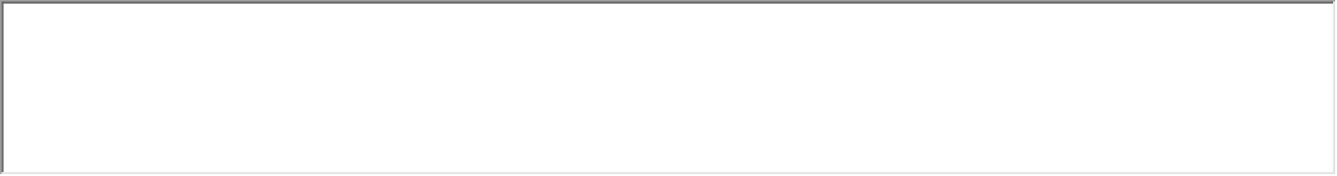statement of all reasons why wages are not owed). Affidavits and documents in support of this are attached
hereto as Exhibit 2.

CERTIFICATE OF SERVICE

I hereby certify that on this day of, a copy of the foregoing Complaint was served on by (state method of service).
Department of Labor, Licensing and Regulation
Division of Labor and Industry
Employment Standards Service
1100 North Eutaw Street, Room 607
Baltimore, MD 21201
Telephone Number: (410) 767-2357 • Fax Number: (410) 333-7303
E-mail: dldliemploymentstandards-dllr@maryland.gov

Rev: 9/2015
Rev: 4/2019

