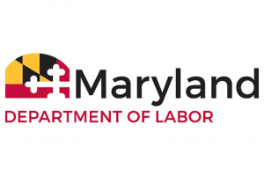
DIVISION OF LABOR AND INDUSTRY
Office of the Commissioner
1100 North Eutaw Street, room 600
Baltimore, Maryland 21201

AGENDA
MEETING OF THE BOARD OF BOILER RULES

Friday, September 11, 2020
10:00 a.m.
(Virtual meeting)

1. Call to Order – Chairman Dr. Ashwani Gupta

2. Introduction of Board Members, DLI Staff and Members of the Public – Chairman Gupta.

3. Approval of Minutes from the Previous Meeting – Chairman Gupta.

4. Comments from Commissioner of Labor & Industry, Matthew Helminiak

5. Report of Legislative Activity – Commissioner’s Office

6. Report of Regulatory Activity – Commissioner’s Office
- Updating the dates of the currently listed codes/standards to the latest version.
- Referencing NBIC Part 1, Supplement S3 in COMAR. (This addresses CO2 monitoring for bulk CO2 storage.)
7. Program Update – Steve Noonan, Chief Boiler Inspector

8. Perdue Variance Request.

9. Other Business – Chairman Gupta.

10. Date of Next Meeting

11. Adjournment

