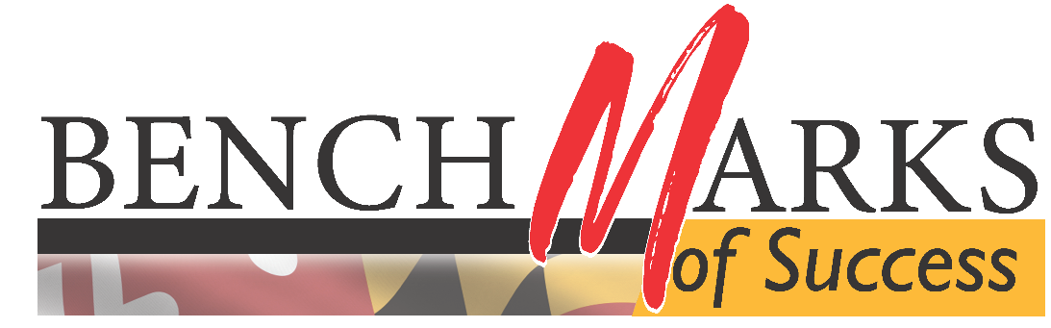
Newsletter
Data Analysis
2022

Table of Contents
General Information 3
Unique Open Rate 3
Total Recipients 4
Featured Topics 5
Appendix 6

General Information
The Benchmarks of Success Communications Committee released 10 newsletters in 2022:
Issue Number | Release Date |  | Issue Number | Release Date
#32 | 1/25 |  | #37 | 7/5
#33 | 2/22 |  | #38 | 8/30
#34 | 3/29 |  | #39 | 9/29
#35 | 4/26 |  | #40 | 10/25
#36 | 5/31 |  | #41 | 12/13

Unique Open Rate
The “Unique Open Rate” is a count of how many distinct viewers opened the newsletter at least once. The chart below compares the Unique Open Rate for the newsletter for each of the 10 issues released during 2022:

The average Unique Open Rate for the 10 issues released during 2022 was 25%.

Total Recipients
The newsletter is distributed to email addresses using the GovDelivery platform. The following table displays the total number of recipients the newsletter was emailed to for each of the ten newsletters issued during 2022.

The chart below shows the average number of recipients the newsletter has been emailed to each year between 2018 and 2022.

The 2022 total recipients reflects the introduction of the emails from BoS eLearning participants.

Featured Topics
In most cases, the Communications Committee identifies a feature topic for newsletter issues, and align articles and success stories with the theme. Below is an inventory of the topics featured, by month, for the run of the newsletter.
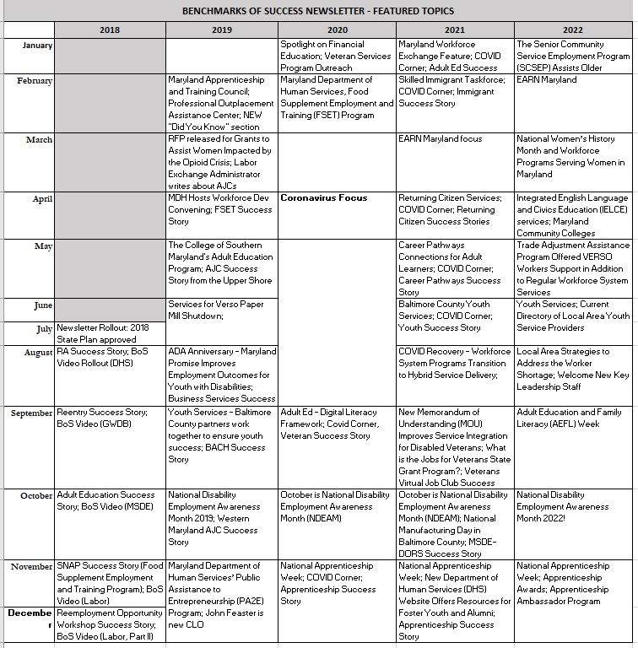
We compared the Unique Open Rates for repeated feature topics over the run of the newsletter to identify any patterns in reader interests.
The highest Unique Open Rate across all issues was 48% for Issue #18, but since this Issue focused on informing workforce staff regarding pandemic-related closures, it was not a repeat topic. Nine topical areas have been featured more than once. They are ranked as follows:
- Adult Education – 29%
- Veterans – 29%
- Reemployment Services – 26%
- Apprenticeship – 24%
- Department of Human Services Programs – 23%
- Services for the Disabled (DORS) – 22%
- Returning Citizens – 22%
- Youth – 22%
- EARN Maryland – 15%
A full breakdown of topics appears in the Appendix.

Appendix
Breakdown of Unique Open Rates by Topic
Focus Topic | Issue # | Publication Dates | Unique Open Rate
Apprenticeship | 2 | 8/21/2018 | 32%
 | 7 | 2/21/2019 | 30%
 | 21 | 12/3/2020 | 15%
 | 41 | 12/13/22 | 19%
Avg. |  |  | 24%
Focus Topic | Issue # | Publication Dates | Unique Open Rate
Returning Citizens | 3 | 9/19/2018 | 32%
 | 25 | 4/23/2021 | 12%
Avg. |  |  | 22%
Focus Topic | Issue # | Publication Dates | Unique Open Rate
Veterans | 16 | 1/16/2018 | 31%
 | 29 | 9/20/2021 | 26%
Avg. |  |  | 29%
Focus Topic | Issue # | Publication Dates | Unique Open Rate
Reemployment Services | 6 | 12/21/2018 | 26%
 | 11 | 6/20/2019 | 29%
 | 28 | 8/23/2021 | 30%
 | 36 | 5/31/2022 | 17%
 | 38 | 8/30/22 | 18%
Avg. |  |  | 26%

Focus Topic | Issue # | Publication Dates | Unique Open Rate
Adult Education | 4 | 10/19/2018 | 29%
 | 19 | 9/29/2020 | 37%
 | 26 | 6/3/2021 | 33%
 | 35 | 4/26/2022 | 15%
 | 39 | 9/29/22 | 32%
Avg. |  |  | 29%
Focus Topic | Issue # | Publication Dates | Unique Open Rate
EARN Maryland | 24 | 3/24/2021 | 13%
 | 33 | 2/22/2022 | 17%
Avg. |  |  | 15%

Focus Topic | Issue # | Publication Dates | Unique Open Rate
Department of Human Services Programs | 5 | 11/20/2018 | 25%
 | 9 | 4/22/2019 | 15%
 | 15 | 12/5/2019 | 24%
 | 17 | 2/27/2020 | 27%
Avg. |  |  | 23%
Focus Topic | Issue # | Publication Dates | Unique Open Rate
Employment Services for Individuals with Disabilities | 12 | 8/1/2019 | 30%
 | 14 | 11/1/2019 | 26%
 | 20 | 10/22/2020 | 13%
 | 30 | 10/26/2021 | 9%
 | 40 | 10/25/22 | 31%
Avg. |  |  | 22%

Focus Topic | Issue # | Publication Dates | Unique Open Rate
Youth | 12 | 8/1/2019 | 30%
 | 13 | 9/24/2019 | 30%
 | 31 | 8/6/2021 | 10%
 | 37 | 7/5/22 | 17%
Avg. |  |  | 22%

Focus Topic | Issue # | Publication Dates | Unique Open Rate
Senior Community Services Employment Program | 32 | 1/25/2022 | 33%
Avg. |  |  | 33%

Focus Topic | Issue # | Publication Dates | Unique Open Rate
Women’s History Month | 33 | 3/29/2022 | 34%
Avg. |  |  | 34%

