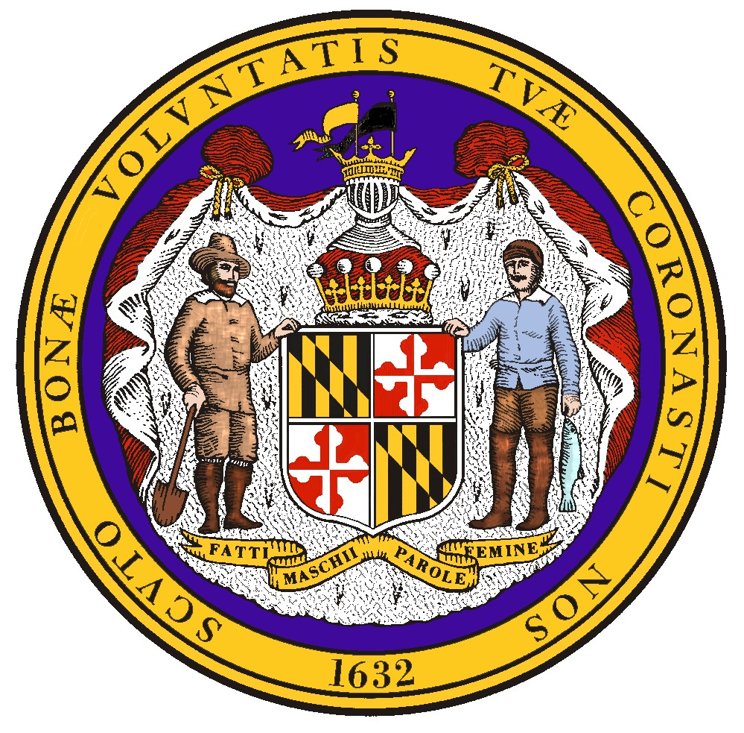
FY 2025 State OSHA Annual Report (SOAR): Maryland Occupational Safety and Health
FT

Evaluation Period: October 1, 2024- September 30, 2025 Prepared by: Maryland Occupational Safety and Health Submitted: February 6, 2026
A
DR

Wes Moore, Governor Portia Wu, Secretary Devki Virk, Commissioner

Table of Contents:
- Executive Summary……………………………………………………………………... 2
- Summary of Annual Performance Plan Results………………………………………. 4
- Progress Toward Strategic Plan Accomplishments: Performance & Activity Results 4
- Mandated Activities……………………………………………………………………... 8
- Special Measures of Effectiveness/Special Accomplishments………………………… 14
- Adjustments or Other Issues……………………………………………………………. 15
DRAFT

Executive Summary

Federal Fiscal Year 2025 (FFY25) was the third year in the current five-year Strategic Plan. Maryland Occupational Safety and Health (MOSH) met its annual goals for the year and is on track to meet the projected five-year goals.

Maryland Heat Stress Standards
MOSH began enforcement of the Maryland Heat Stress Standards and continued outreach and compliance assistance with the new regulations in FFY25. MOSH Enforcement responded to 220 heat stress complaints through letters, non-formal complaint processes, and formal complaint inspections. Fifty formal complaints of heat were investigated by inspection, though not all resulted in violations of the heat stress standard. Overall, MOSH issued heat-related citations in 50 enforcement inspections, resulting in 157 violations of the heat stress standards. Heat stress education and resources were provided to all employers during inspections. MOSH conducted targeted heat compliance assistance using injury and illness data from the OSHA Information Tracking Application (ITA) directed to employers with recordable work-related heat illnesses in 2024.
DRAFT

MOSH Industrial Hygiene staff conducted in-person and virtual heat stress training to educate employers and the public about the new standards. Outreach initiatives included targeted engagement and industry-specific webinars for: Warehousing and Distribution; Agriculture and Landscaping; Restaurants, Commercial Kitchens, and Bakeries; and Laundries and Dry Cleaners. More than 2,300 people participated in the Heat Stress presentations. Several new heat stress resources for employers were developed in English and Spanish and posted on the MOSH website, including: Heat Stress Standards; One-Page Fact Sheet; Summary of Key Requirements; and Model Heat Illness Prevention Plan. MOSH plans to add additional resources and training offerings in FFY26. Understanding that empowering Maryland workers was important to successful implementation, in a first for DLI, MOSH began a pilot social media campaign of bilingual outreach to educate and raise awareness about the new heat standard and its protections.

The Davis Martinez Public Employee Safety and Health Act
In 2025, the Maryland General Assembly passed the Davis Martinez Public Employee Safety and Health Act, which amended the MOSH Act in several ways to enhance protections for public sector employees. The Public Employee Safety and Health Act went into effect on October 1, 2025. As part of the law’s implementation, MOSH has established a Public Employees’ Safety and Health Unit to administer and oversee MOSH’s public sector enforcement work as part of the agency’s comprehensive program to promote safe and healthful working conditions for employees of public bodies. Significantly, the Act also repealed a 50-year-old statutory exemption that did not permit MOSH to assess civil monetary penalties to public bodies. Now, public bodies may be subject to civil monetary penalties for violations

resulting from MOSH inspections.¹ In addition to new citation service and reporting requirements meant to increase awareness and accountability, the Act requires MOSH to develop and adopt a new workplace violence standard to better protect employees of public bodies by October 1, 2026.

MOSH has prioritized education and outreach efforts to engage with public sector employers to help promote compliance with the Public Employee Safety and Health Act. A focal point of MOSH’s efforts has been raising awareness about the value of MOSH Consultation. Prior to the Act’s effective date, MOSH shared compliance assistance and MOSH consultation information with a diverse group of 1,937 stakeholders and separately targeted state agencies with outreach by partnering with the Maryland Department of Budget and Management to share valuable resources. In FFY25, MOSH planned additional public sector outreach activities and partnerships, including webinars focused on injury and illness recordkeeping, that the agency will complete in FFY26.

MOSH Enforcement FFY25 Highlights* :
DRAFT
- MOSH investigated 15 work-related fatality events in FFY25, one of the lowest years in MOSH history.
- 1,120 safety inspections identifying 5,750 hazards, which resulted in 4,578 citations.
- 160 health inspections identifying 1,055 hazards, which resulted in 805 citations.
- Per compliance inspection, MOSH Compliance Officers and Hygienists identified an average of
2.78 violations classified as serious, willful, or repeat, and 2.48 violations classified as other-than-serious, for a total average of 5.26 violations per inspection.
- Violations were identified in more than 85% of enforcement inspections.
- Programmed inspections accounted for 73% of total inspections conducted.
- MOSH Compliance Officers and Hygienists conducted 82 Public Sector inspections.
- More than 95% of all violations were sustained as issued (i.e., not vacated or reclassified) following citation issuance, pre- and post-contest.

*Data derived from OSHA-provided end-of-year SAMM, SIR, and OIS Standards Cited reports.

¹ On September 10, 2025, the issuance of MOSH Instruction 25-3 canceled MOSH Instruction 76-1 and removed the longstanding public sector employer penalty exemption.

- Summary of Annual Performance Plan Results & III. Progress Toward Strategic Plan Accomplishments
DRAFT

Strategic Goal 1: Improve workplace safety and health through compliance assistance and enforcement of occupational safety and health regulations.
Performance Goal 1.1: Total Reduction in the Fatality Rate by 1% (5% by end of FFY 2027)
Performance Goal 1.2: Reduce the rate of occupational injuries and illnesses in Maryland’s private sector by 1% (5% by end of FFY 2027)
Performance Goal 1.3: Reduce the rate of occupational injuries and illnesses in Maryland’s State and local government sector by 1% (5% by the end of FFY 2027)
Unit Responsible  (data source) | Performance Indicator | Result | Comments
Enforcement/ Compliance Assistance  Consultation  OSHA Information System (OIS) Data for various metrics  (Bureau of Labor Statistics [BLS] survey of occupational injuries and illnesses) | Perform inspection and intervention activity in the following areas:  Industry FFY2025 Projected  - Construction (NAICS 23) 805  - Other high-hazard industries 291  (NAICS 11, 5617, 562, 622-624, 71, 721)  - Public Sector 65  - Manufacturing (NAICS 31-33) 79  - Trade, Transportation, Utilities 79  (NAICS 2213, 424, 44-45, 48-49)  Conduct the following number of Consultation visits:  Industry FFY2025 Projected  - Construction (NAICS 23) See CAPR  - Other high-hazard industries See CAPR  (NAICS 11, 5617, 562, 622-624, 71, 721)  - Public Sector 107  - Manufacturing (NAICS 31-33) See CAPR  - Trade, Transportation, Utilities See CAPR  (NAICS 2213, 424, 44-45, 48-49) | Industry 2025 Actual  - Construction (NAICS 23) 809  - Other high-hazard industries 104  (NAICS 11, 5617, 562, 622-624, 71, 721)  - Public Sector 87  - Manufacturing (NAICS 31-33) 103  - Trade, Transportation, Utilities 83  (NAICS 2213, 424, 44-45, 48-49)  Industry 2025 Actual  - Construction (NAICS 23) See CAPR  - Other high-hazard industries See CAPR  (NAICS 11, 5617, 562, 622-624, 71, 721)  - Public Sector 76  - Manufacturing (NAICS 31-33)….See CAPR  - Trade, Transportation, Utilities….See CAPR (NAICS 2213, 424, 44-45, 48-49) | NOTE: Maryland’s private sector Days Away, Restricted, and Transfer (DART) rate for reference year 2024 was 1.3 injuries and illnesses per 100 full-time equivalent  workers; 2023’s rate was 1.4.  MOSH had one 23(g) public sector consultant. All parameters for consultation can be found in the FFY24 Consultation Annual Program Report (CAPR).

DRAFT

Strategic Goal 2: Promote a safety and health culture through Cooperative Programs, Compliance Assistance, On-site Consultation Programs, Outreach, Training, and Education.
Performance Goal 2.1: Increase Recognition Programs from 19 to 20 (3 new Recognition programs by end of FFY 2027)
Unit Responsible (data  source) | Performance Indicator | Result | Comments
Compliance Assistance (Report from Consultation unit and Voluntary Protection Program [VPP] unit) | Increase Recognition Programs by 1 new company for FFY25. | There were no new sites added for FFY25. | MOSH conducted six recertification visits and is actively working to add new sites.
Performance Goal 2.2a: Increase Cooperative Compliance Partnerships (CCP) from 103 to 105 in 2025 (this is the total number of signed cooperative partnerships, not the total number of active cooperative partnerships) (add 8 new cooperative partnerships by the end of FFY 2027)
Unit Responsible (data source) | Performance Indicator | Result | Comments
Compliance Assistance (Report from Partnership and Alliance unit) | Increase MOSH Cooperative Compliance Partnerships by 1 in 2025. | MOSH conducted one initial visit in FFY25. | MOSH is on track to meet the 5-year goal.
Performance Goal 2.2b: Maintain SPECS partnerships at 5 (this is the total number of signed cooperative partnerships, not the total number of active cooperative partnerships)
Unit Responsible (data source) | Performance Indicator | Result |  | Comments
Compliance Assistance (Report from training and education unit) | Maintain SPECS partnerships at 5. | There were 0 new SPECS sites added for FFY25. |  | There were 0 new SPECS sites added for FFY25.
Performance Goal 2.3: Ensure a minimum of 12 MOSH outreach and training events annually
Unit Responsible (data source) | Performance Indicator | Result |  | Comments
Compliance Assistance (report from training and education unit) | MOSH will enact outreach and training events in the areas covered by MOSH LEPs, current SST, and Federal NEPs, including formal training, workshops, seminars, speaking engagements, conferences, and informal worksite training. | MOSH Outreach and Education conducted 51 speaking engagements, delivered in-person and virtually. The unit provided three in-house training sessions for newly appointed Compliance Safety and Health Officers (CSHO) and facilitated two all-staff meetings focused on safety and health updates. The unit also conducted three online S&H webinars, two in-person safety seminars, and participated in nine safety conferences. |  | MOSH exceeded its goal for FFY25 and plans to continue to expand training via webinars, virtually-led, and in-person instruction for employers and the public in FFY26.

T
DRAF

Performance Goal 2.4: Continue to emphasize public sector initiative programs to leverage agency resources in the following areas: MOSH Enforcement, partnerships/alliances, training, and consultation.
Unit Responsible (data source) | Performance Indicator | Result | Comments
Compliance Assistance (report from training and education unit) | Number of initiatives enacted by the agency to increase focus on public sector workplaces in the State of Maryland. | (1) The Davis Martinez Act continues to increase awareness of safety and health in the public sector, and MOSH has seen rises in compliance assistance requests, outreach activities, and education opportunities as a result. (2) MOSH continues to work with the Workers’ Compensation Commission on reciprocal sharing of injury and illness data and lays the foundation for joint efforts regarding public sector risk reduction; (3) MOSH 23(g) Consultation staff continue to actively participate in the State Employee Risk Management Association (SERMA). | MOSH is actively engaged in seeking opportunities to increase safety and health in public sector locations.  Public sector inspections, targeting efforts, and outreach initiatives have all increased in FFY25, due in part to the passing of the Davis Martinez Act.

Performance Goal 3.1: Initiate 100% of fatality and catastrophe inspections within one working day of notification
Unit Responsible (data source) | Performance Indicator | Result | Comments
Enforcement/ Compliance Assistance (OIS) | Percentage of fatal case investigations initiated within 1 working day of notification. | According to the 2025 EOY State Activity Mandated Measures (SAMM) Measure 10, MOSH investigated 15 workplace fatality events, all of which were opened within one day of notification. | MOSH met its goal of 100% of fatality inspections initiated within one working day of notification.
Performance Goal 3.2: Initiate inspections of serious complaints within five working days of notification
Unit Responsible (data source) | Performance Indicator | Result |  | Comments
Enforcement/ Compliance Assistance (OIS/IMIS)  SAMM Report | Serious complaint inspections are initiated within an average of 5 days of notification. | In FFY25, MOSH initiated complaint inspections within an average of 2.93 days. |  | MOSH maintained complaint tracking and auditing processes that prevented outliers from exceeding 5 days and reduced the average time from FFY24.

D

Performance Goal 3.3: Percent of discrimination complaint investigations completed within 90 days maintained at least at 90%
Unit Responsible (data source) | Performance Indicator | Result | Comments
Enforcement/ Compliance Assistance (whistleblower web-based application) | Percent of discrimination complaint investigations completed within 90 days. | 29.63% of 11c investigations were completed within 90 days. | Seven MOSH safety investigators and two public sector consultants investigate whistleblower complaints in addition to safety inspections.

Program Activity Projections:
R
AFT

Total Inspections- Enforcement
 | Safety |  | Health
 | Projected | Actual | Projected | Actual
Private Sector Inspections | 1062 | 1055 | 97 | 143
Public Sector Inspections | 50 | 65 | 10 | 17
Total | 1112 | 1120 | 107 | 160

Consultation Visits
 | Projected | Actual | Total Visits
21(d) Projected Visits | * | * | *For results of the 21(d) consultation unit please see the FFY25 Consultation Annual Program Report (CAPR)  **There were 76 public sector 23g consultation visits conducted. Safety conducted 61 initial visits and 13 follow-up visits. One public safety consultant was still ‘in-training.’ Health conducted 2 initial and 0 follow-up visits.  ***Health visits for the public sector require the use of a private sector consultant.  MOSH Consultation had one health consultant retire in August and, as a result, only one health consultant was available for two months of the fiscal year.
23(g) Projected Visits Safety** | 100 | 74
23(g) Projected Visits Health*** | 7 | 2
Total Visits | 107 | 76

- Mandated Activities Enforcement
DRAFT
According to the OSHA-derived SAMM report, MOSH Compliance Officers and Hygienists opened
1,280 enforcement inspections in FFY25, including 1,120 safety and 160 health inspections, achieving over 100% of both safety and health inspection goals for the year. MOSH Enforcement responded to 15 fatality events and exceeded all of its projected inspection goals while ensuring that identifying and removing hazards from workplaces and protecting employees in the state of Maryland remained a top priority.
Compliance officers continued to focus on the Maryland industries with high injury and illness rates. Of the 1,280 enforcement inspections, 903 were conducted under one or more of the state’s Local Emphasis Programs (LEPs), and 753 of the inspections were conducted under one or more of the adopted National Emphasis Programs (NEP). MOSH compliance officers investigated 125 accidents, including 15 fatalities. Of the 15 workplace fatality events, all were opened within one day of notification. There were no instances where a Compliance Officer was not able to gain entry to a facility after an employer originally denied the inspection.
End-of-year SAMM data shows MOSH initiated complaint inspections, on average, in 2.93 days, decreasing from 3.52 in FFY24. Complaint investigations were successfully initiated within an average of 2.67 days, decreasing from 2.72 days in FFY24. Both were within the negotiated FRL of 5 days and 8 days, respectively.
Per SAMM Measure 5, MOSH Compliance Officers and Industrial Hygienists averaged 2.78 serious, willful, or repeat violations, an increase from 2.57 in FFY24. Other-than-serious violations averaged 2.48 per inspection, for a total average of 5.26 violations per case file in FFY25.
SAMM Measure 9 (In Compliance Rate) shows there were 1,074 qualifying safety inspections completed, with 155 (14%) in compliance, down from 19% in FFY24. There were 137 qualifying health inspections completed, with 31 (22%) in compliance, down from 29% in FFY24. The MOSH in compliance rate is far below the national average, reflecting successful targeting and hazard risk reduction with limited resources.
During FFY25, the average lapse time for safety inspections was 41.7 days, and the average lapse time for health inspections was 77.6 days. The number for safety was significantly lower than both the state plan and federal averages, while the number for health was on par with the federal average.
MOSH adjusted the penalty size reductions for employers, effective April 15, 2025 (MOSH Instruction 25-1), which increased the penalty amounts for all except the largest employers. The

average penalty per serious violation for all employers in FFY25 was $981.15, a 9% increase from FFY24, and will further rise in FFY26 with new penalty size reductions and the addition of public sector penalties in effect for a full year. MOSH issued an average penalty of $858.00 per serious citation for employers with 25 employees or fewer, $1,181.93 for employers between 26 and 100 employees, $1,693.46 for employers between 101 and 250, and $1,747.85 for employers with more than 250 employees.
DRAFT
More than 6.5% of all MOSH inspections were completed in the public sector, exceeding the FFY25 estimated goal of 5%. MOSH continues to use an LEP to focus on public sector establishments and the number of public sector inspections conducted has increased 19% in the last three years. With increased awareness of safety and health in the public sector, due in part to the Davis Martinez Act, MOSH expects that public sector inspections will continue to rise in FFY26.
Based on the most recent U.S. Bureau of Labor Statistics results for reference year 2024, Maryland’s private industry total recordable case incidence rate (TRC) was 2.2 injuries and illnesses per 100
full-time equivalent (FTE) workers, slightly below the U.S. private sector’s rate of 2.3, and a decrease from 2.3 TRC in 2023. Maryland’s private sector Days Away, Restricted, and Transfer (DART) rate for reference year 2024 was 1.3 injuries and illnesses per 100 full-time equivalent workers; 2023’s rate was 1.4. The continued decrease in both TRC and DART rates reinforces MOSH’s targeted enforcement activities in high-hazard industries and aligns with its strategic goals to improve workplace safety and health.

Consultation- Public Sector
There were 76 public sector visits conducted; 74 were safety-related, and two were health-related. Of the visits conducted, 65% were in correctional facilities, while the remaining 35% were conducted in other public service sectors such as conservation programs, public health programs, and park programs. The program did not meet its goal of 107 inspections for FFY25 due to several factors: a health consultant retiring in August of 2025; continued training of a safety consultant necessary to reach the level of skill required to conduct visits independently; and not receiving the anticipated influx of requests related to the new heat stress regulation. All of the public sector requests for consultation service were fulfilled in a timely manner and employer surveys received by the Consultation unit rated the public sector consultants’ services as “excellent.”
Consultation supported the Outreach unit by providing consultants to fulfill speaker and seminar requests in public sector industries. Targeted outreach focused on compliance with the new heat stress regulations was directed to corrections, natural resources, public health services, and public works. The targeted outreach included email campaigns, speaking at events, and working directly with State Agencies to offer heat stress information and consultation resources.

MOSH had two public sector safety consultants in 23(g) for FFY25, one of whom was ‘in-training’ for part of the year. When there are specific health concerns on a public sector site, one of the health consultants from the 21(d) program will temporarily transfer to the 23(g) program and perform the health visit; funding modifications between the two budgeted programs are properly allocated.
DRAFT

Whistleblower
The MOSH Whistleblower Unit screens and investigates whistleblower claims that are filed with and referred to the agency. In FFY25, seven (7) CSHOs and two (2) public sector Consultants conducted whistleblower investigations and supported MOSH’s Whistleblower Program in addition to their assigned compliance and consultative work.
In FFY25, MOSH received 94 whistleblower complaints and docketed 42 for full investigations under §5-604 of the Labor and Employment Article, which parallels Section 11(c) of the OSH Act. Four investigations resulted in meritorious findings and compensatory relief of over $139,947.66 for the complainants.

Education Unit
In FFY25, the Training and Education Unit delivered a variety of training programs and outreach initiatives. Safety and health education was provided to employers and the general public through webinars, virtual and onsite presentations, and targeted outreach efforts focused on high-hazard industries.
MOSH expanded its virtual learning opportunities by offering live webinars on high-demand topics, including heat injury and illness prevention and OSHA recordkeeping. The Unit also fulfilled numerous requests for speakers on an array of safety and health subjects such as “This is MOSH,” fall protection, workplace violence, construction site safety, excavation safety, tree care safety, MOSH site inspections, heat stress, recordkeeping requirements, and teen worker safety.
During FFY25, more than 27 employers, institutions, labor unions, and government agencies requested an MOSH speaker for onsite sessions or special events. These engagements reached a total audience of 3,343 employers, workers, and students. MOSH also continued to address the growing need for youth worker safety education. In FFY25, the program provided Youth Worker Safety training to 443 students across seven high school events statewide.
Following the adoption of the Heat Stress Standard in September 2024, MOSH Outreach facilitated several heat-stress-related webinars and presentations, offered both in person and online. Numerous organizations—including unions, state agencies, and employers in both the public and private sectors—requested speakers and compliance assistance. MOSH delivered Heat Stress webinars to the general public and four sector-specific targeted Heat Stress webinars for industries including Warehouse and Distribution; Agriculture and Landscaping; Restaurants, Commercial Kitchens, and

Bakeries; and Laundries and Dry Cleaners. A partnership with Lamar Advertising afforded MOSH the opportunity to raise awareness about Heat Stress on electronic billboards in Reisterstown, Hagerstown, Elkton, and Silver Spring. To support implementation of the Heat Stress Standard, MOSH developed and disseminated four Spanish-language resources (the Standard, Key Requirements, Summary of Key Maryland Requirements, and a Model Program). A new Heat Stress informational webpage was developed, and periodic email blasts were distributed to stakeholders across public and private sectors. The new heat-specific webpage on the MOSH website quickly became MOSH’s most popular single source for helpful, bilingual resources for employees, unions, and employers.
DRAFT

Staff Training
During FFY25, Compliance Safety and Health Officers (CSHOs) participated in both in-person and virtual training sessions offered by the OSHA Training Institute. The agency also conducted
in-house classroom instruction for new CSHOs, covering the MOSH Act, relevant laws and regulations, field safety practices, personal protective equipment, and bloodborne pathogens and hazard communication.
In May 2025, MOSH hosted the OSHA Training Institute (OTI) Course 1310, Investigative Interviewing Techniques, at its Training Center in Hunt Valley. Seventeen CSHOs attended this training. Biannual training sessions were delivered during all-staff meetings, with more than 50 employees attending each session. In collaboration with ARTBA, MOSH provided two in-person OSHA 10-hour Construction in Roadway courses to both CSHOs and the public. MOSH also participated in multiple OSHA safety campaigns throughout the year.

Instructions and Standards Notices
MOSH issued a Standard Notice for the Maryland Heat Stress Standards, which became effective at the start of FFY2025.
- Standard Notice 25-1 - Heat Stress Standards - Effective September 30, 2024
MOSH issued three new instructions in FFY25, including:
- Instruction 25-1 - Penalty Adjustment Factors for Establishment Size - 4/11/2025; effective 4/15/2025
- Instruction 25-2 - Local Emphasis Program for High Hazard Industries in Maryland - 5/16/2025; effective 5/16/2025
- Instruction 25-3 - Cancellation of MOSH Instruction 76-1 - 9/10/2025; effective 10/1/2025

*Additional instructions are expected to be adopted in the first part of FFY26. MOSH continues to successfully adopt outstanding OSHA directives. Please see the website for the most
DRAFT
up-to-date list.

Cooperative Compliance Partnerships (CCP) & Voluntary Protection Program (VPP) - Star Only
The Cooperative Compliance Partnership program conducted one initial site visit in FFY25. Several new applications are currently undergoing review and are likely to become new partnerships in FFY26.
MOSH conducted six renewal inspections in FFY25 and has plans to conduct three renewal inspections in FFY26. No new sites were added to the Voluntary Protection Program in FFY25.
MOSH VPP staff attended the Region III VPPPA conference held in May in Hershey, PA and is planning to attend the Region III VPPPA conference in FFY26. Three MOSH compliance staff completed the OSHA VPP Team Leader Training course (5500) offered by the OSHA Training Institute.

Research and Statistics
In July 2025, the MOSH Research and Statistics unit completed the reference year 2024 data collection for the Bureau of Labor Statistics (BLS) Survey of Occupational Injuries and Illnesses (SOII) program. The statistics generated from this employer-based survey are the U.S. government’s official accounting of the safety and health issues facing America’s workplaces. The SOII charts the nature and magnitude of occupational injuries and illnesses across the United States. The dedication and perseverance of the Research and Statistics staff helps ensure that MOSH has reliable and timely occupational injury and illness data at its disposal for industry outreach initiatives, targeted enforcement, and other surveillance purposes.
F
T
Highlights of the Maryland Survey of Occupational Injuries and Illnesses
- Maryland’s private industry TRC rate of 2.2 in 2024 was lower than the 2023 rate of 2.3. Maryland's TRC rate has generally been on a decline, with few exceptions, since a 2003 TRC of 4.1.
A
- Maryland’s private sector Days Away, Restricted, and Transfer (DART) rate for reference year 2024 was 1.3 injuries and illnesses per 100 full-time equivalent workers; 2023’s rate was 1.4.
- Maryland's private construction of buildings major group had a TRC rate of 1.6 compared to the national private construction of buildings major group TRC rate of 2.2.
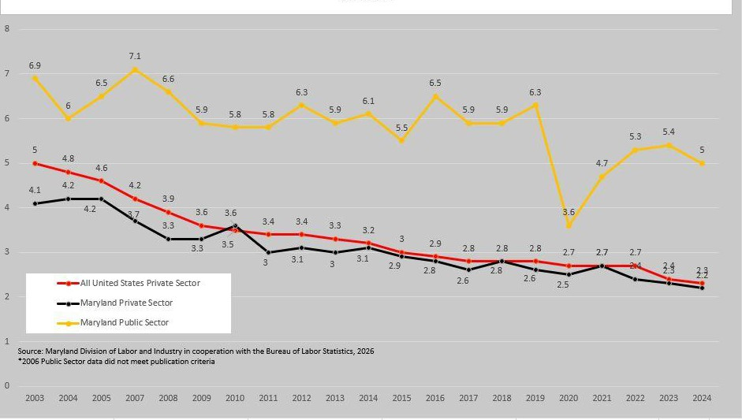
- Maryland state hospitals had nearly twice the TRC rate as the national TRC rate for state hospitals at 13.0 and 6.9, respectively.
DR

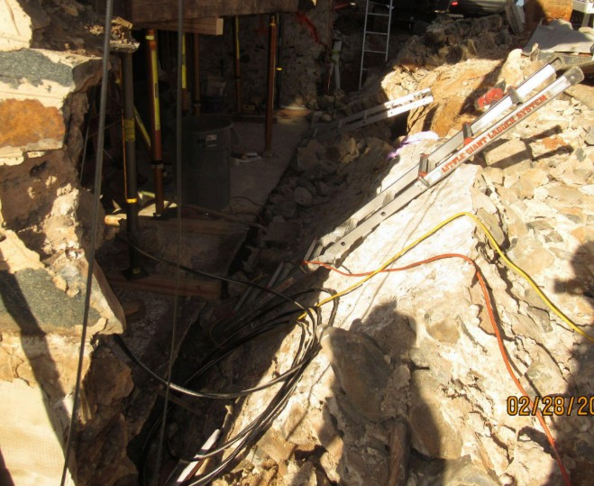
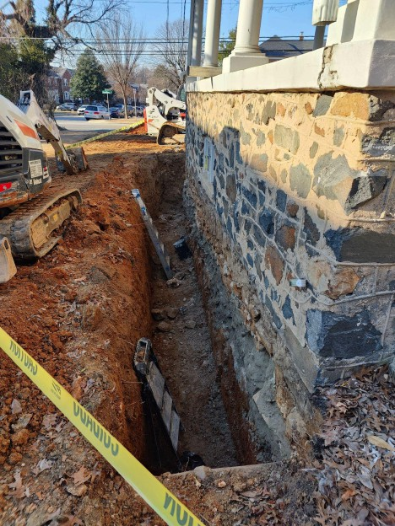
Special Measures of Effectiveness/Special Accomplishments Case Highlights - Enforcement
DRAFT

Excavation Double Fatality
In February 2025, MOSH was notified of a foundation collapse at a residential home where two employees were pinned inside a trench after a 20-inch-thick fieldstone foundation wall fell on top of them. The employees were performing repairs to the outside of the cracked, deteriorating foundation wall from inside the trench, which measured 6 feet deep, 34 feet long, and 3 feet wide, when the wall collapsed, trapping two employees underneath who suffered fatal injuries.

The homeowner had hired the basement waterproofing and foundation repair contractor to rehabilitate the basement foundation wall of the home, which had been cracked and deteriorating since at least 2015. Work initially began in early November 2024, but stopped after employees reported that stones from the wall were falling into the trench. Work resumed in February 2025 after the employer provided steel mesh wire rolls to contain loose stones. Employees were tasked with excavating underneath the unsupported wall in order to install concrete piers underneath.
The foreman had reported safety concerns to management multiple times throughout the project and had requested shoring from his direct supervisor, but no shoring was ever provided. The employer failed to provide cave-in protection, wall braces, or anything to support the wall, and did not provide the foreman, or the crew, with excavation/trench training.

As a result of the circumstances surrounding the investigation, the employer received four Willful-Serious, eight Serious, seven Other-Than-Serious citations, and an initial assessed penalty of $355,850. The employer was also placed into the Severe Violator Enforcement Program and enhanced abatement actions negotiated as part of the settlement. All citations were sustained as issued and MOSH and the employer agreed to a negotiated penalty amount of
$120,000.

Adjustments or Other Issues Organizational Changes
DRAFT
On April 30, 2025, MOSH welcomed Assistant Commissioner Christopher Williamson. A native
West Virginian who adopted Maryland as home over a decade ago, Chris has spent his career promoting worker protections, first as a Congressional staffer, and then at the U.S. Department of Labor and the National Labor Relations Board, and, most recently serving as Assistant Secretary of Labor for the federal Mine Safety and Health Administration (MSHA).
MOSH hired six safety compliance officers in FFY25 and re-hired one industrial hygienist. MOSH lost six safety compliance officers and four industrial hygienists (three in enforcement and one in consultation). A state-wide hiring freeze in July 2025 slowed recruitment efforts in the latter part of the fiscal year.

