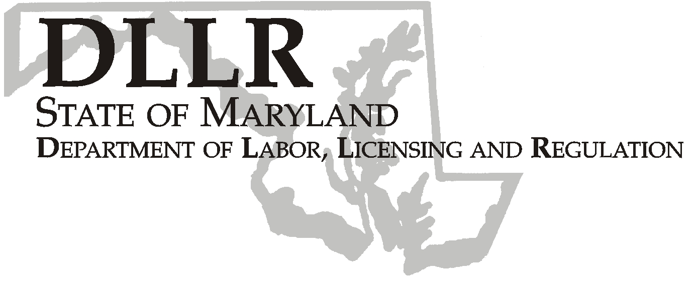
MARTIN O’MALLEY, Governor
ANTHONY G. BROWN, Lt. Governor
THOMAS E. PEREZ, Secretary

Division of Labor and Industry

J. Ronald DeJuliis, Commissioner

DLLR Home Page • http://www.dllr.state.md.us
DLLR E-mail • dli@dllr.state.md.us

MOSH STANDARDS NOTICE 06-1

TO: All MOSH Personnel

FROM: Roger Campbell
Assistant Commissioner

SUBJECT: Revisions relating to Updating OSHA Standards based on National Consensus Standards; General, Incorporation by Reference; Hazardous Materials, Flammable and Combustible Liquids; General Environmental Controls, Temporary Labor Camps; Hand and Portable Powered Tools and Other Hand-Held Equipment, Guarding of Portable Powered Tools; Welding, Cutting, Brazing, Arc Welding and Cutting; Special Industries, Sawmills.

PURPOSE: To delete from OSHA standards three references to national consensus standards and two references to industry standards that are outdated, and to clarify employer obligations under the applicable OSHA standards and reduce administrative burdens on employers.

Effective Date: July 17, 2006

Issuance Date: February 20, 2008

- Background

- On June 27, 2006, the Commissioner of Labor and Industry adopted through incorporation by reference under COMAR 09.12.31 Maryland Occupational Safety and Health Act – Incorporation by Reference of Federal Standards, the revisions relating to Updating OSHA Standards based on National Consensus Standards; General, Incorporation by Reference; Hazardous Materials, Flammable and Combustible Liquids; General Environmental Controls, Temporary Labor Camps; Hand and Portable Powered Tools and Other Hand-Held Equipment, Guarding of Portable Powered Tools; Welding, Cutting, Brazing, Arc Welding and Cutting; Special Industries, Sawmills, published in 70 FR 53925 – 53929 (September 13, 2005). This action, which was proposed for adoption in 33:10 Md. R. 895 (May 12, 2006), has been adopted as proposed. This action was recommended to the Commissioner of Labor and Industry by the Maryland Occupational Safety and Health Advisory Board pursuant to meeting held on January 4, 2006, notice of which was given in accordance with State Government Article, §10-506(c), Annotated Code of Maryland.

- Action

1. MOSH Compliance Supervisors and Consultation Supervisors shall ensure that all Compliance Officers are
Provided training on the contents of this notice.

________________________________________ ________
Roger Campbell, Assistant Commissioner MOSH Date

Attachment

cc: J. Ronald DeJuliis, Commissioner, Division of Labor and Industry
Craig D. Lowry, Deputy Commissioner, Division of Labor and Industry
General Jon Krasnoff, Assistant Attorney
Office of Administrative Hearings
Keeping Maryland Working and Safe
TEL: 410-767-2215 ⋅ FAX: 410-767-2003
TTY USERS, CALL VIA THE MARYLAND RELAY SERVICE
1100 N. EUTAW STREET
BALTIMORE, MD 21201

