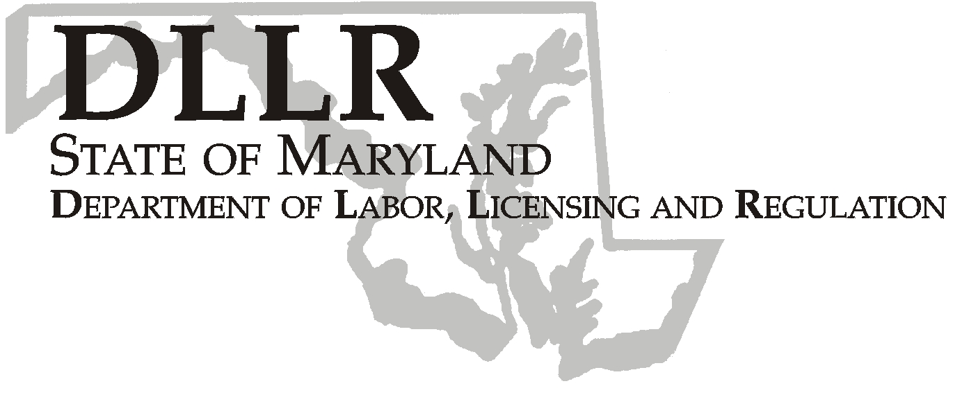
MARTIN O’MALLEY, Governor
ANTHONY G. BROWN, Lt. Governor
THOMAS E. PEREZ, Secretary

Division of Labor and Industry

J. Ronald DeJuliis, Commissioner

DLLR Home Page • http://www.dllr.state.md.us
DLLR E-mail • dli@dllr.state.md.us

MOSH STANDARDS NOTICE 07-3 (Revised)

To: All MOSH Personnel

From: Roger Campbell
Assistant Commissioner

Subject: Adoption and Enforcement of revisions to MOSH Regulation 09.12.23
Prohibition on Smoking in an Indoor Place of Employment

Cancellation: MOSH Standards Notice 94-2; MOSH Standards Notice 07-3 dated February 20, 2008

Effective Date: September 17, 2007 through March 16, 2008 (Emergency Action)
February 9, 2009 (Final Action)
Issuance Date: August 28, 2009

- Background

  - Effective August 1, 1994, the Commissioner of Labor and Industry adopted a regulation, COMAR 09.12.23, Prohibition on Smoking in an Enclosed Workplace.
  - On July 22, 1994, judicial action stayed the enforcement of COMAR 09.10.23. H & G Restaurant, Inc., et al. v. William A. Fogle, et al. Case No. CG 2460, Circuit Court for Talbot County.
  - On February 24, 1995, the Court of Appeals vacated the stay. William A. Fogle, et al. v. H & G Restaurant, Inc., et al., Case No. 69, September Term, 1994.
  - On March 28, 1995, COMAR 09.12.23, Prohibition on Smoking in an Enclosed Workplace went into effect.
  - On May 17, 2007, Governor Martin O’Malley signed the Clean Indoor Air Act of 2007. The Act requires that the Maryland Department of Health and Mental Hygiene and the Maryland Department of Labor, Licensing, and Regulation adopt certain regulations, and report to the General Assembly regarding their enforcement efforts and the effect of their enforcement efforts.
  - It is the intent of the General Assembly that the State protects the public and employees from involuntary exposure to environmental tobacco smoke in indoor areas open to the public, indoor places of employment, and certain designated private areas.
  - On September 17, 2007, The Joint Committee on Administrative, Executive, and Legislative Review granted emergency status to the amendment of Regulations .01 and .03, the repeal of existing Regulation .02 and .04, the adoption of new regulation .02, and the amendment and recodification of existing Regulation .05 to be Regulation .04, under COMAR 09.12.23, Prohibition of Smoking in an Indoor Place of Employment.
TEL: 410-767-2215 ⋅ FAX: 410-767-2003
TTY USERS, CALL VIA THE MARYLAND RELAY SERVICE
1100 N. EUTAW STREET
BALTIMORE, MD 21201
Keeping Maryland Working and Safe

MOSH Standards Notice 07-3 (Revised)
August 28, 2009
Page 2
  - On October 1, 2007, the Commissioner of Labor and Industry adopted the emergency action, and the enforcement of COMAR 09.12.23, Prohibition of Smoking in an Indoor Place of Employment became effective.
  - The purpose of this subtitle is to protect Maryland employees from involuntary exposure to environmental tobacco smoke ("ETS").
  - On January 8, 2009, the Commissioner of Labor and Industry adopted amendments to Regulation .01 under COMAR 09.12.23 Prohibition on Smoking in an Indoor Place of Employment. This action, which was proposed for adoption in 35:24 Maryland. Register 2095—2096 (November 21, 2008), has been adopted as proposed. This action was considered and approved by the MOSH Advisory Board at an open meeting on May 7, 2008.
  - The action amends Regulation .01B(1)(b) under COMAR 09.12.23, Prohibition of Smoking in an Indoor Place of Employment which defined an “indoor place of employment” to include a vehicle other than a private vehicle as used in Health-General Article § 24-505(1), Annotated Code of Maryland, when an employee used it in the course of employment and it was occupied by more than one employee. This action prohibits smoking in a vehicle, other than a private vehicle, when an employee uses it in the course of employment, regardless of the number of employees in the vehicle.
B. Action

- MOSH Compliance personnel will enforce the regulation as amended.

- MOSH Supervisors will hold appropriate training sessions in each region to review the requirements of this action.

________________________________________ ____________
Roger Campbell, Assistant Commissioner MOSH Date

Attachment

cc: J. Ronald DeJuliis, Commissioner, Division of Labor and Industry
Craig D. Lowry, Deputy Commissioner, Division of Labor and Industry
Jonathan Krasnoff, Assistant Attorney General
Office of Administrative Hearings

Symbol Key

- Roman type indicates text existing before emergency status was granted
- Italic type indicates new text.
- [Single brackets] indicate deleted text.

.01 Definitions.
A. (text unchanged)
B. Terms Defined.
(1) “Indoor place of employment” includes, but is not limited to:
(a) (text unchanged).
(b) A vehicle other than a private vehicle as used in Health-General Article § 24-505(1), Annotated Code of Maryland, when an employee uses it in the course of employment [and it is occupied by more than one employee];
(c) — (k) (text unchanged)
(2) — (3) (text unchanged)

