New NRS Tables- WIOA Changes

Table 1: Page 2
Table 2: Page 3
Table 3: Pages 4-6
Table 4: Pages 7-23
Table 4B: Page 24
Table 4C: Page 25
Table 5: Pages 26-30
Table 5A: Page 31
Table 6: Pages 32-33
Remaining Tables: Pages 34-35
Joint report: Page 36
New Left Date Rules: Pages 37-38
Scheduled Services: Pages 39-43
Printing/Saving the Tables: Pages 44-45

Table 1
Participants by Entering Educational Functioning Level, Ethnicity, and Sex

To be a participant, students must have 12 or more hours in the fiscal year, with at least one qualifying period of participation, and be 16 years of age or older at the time of intake (note that some states have higher age requirements for admission). The total on Table 1 should match the totals for Tables 2, 3, and 4, as well as the sums for the rows/columns for Employment Status and Highest Education Level at Entry/Location on Table 6. Table 1 is fiscal year based.
A Period of Participation (PoP) begins when a student enters your program and has 12 or more instructional hours, and ends when the student exits, as demonstrated by not having additional activity 90+ days after the last activity date. It is considered a new entry if the student returns in the current program year after a gap of 90+ days since the last activity. At that time a new PoP will begin. While it is possible for a student to have up to four PoPs within a fiscal year, most students will have one or two.
Entering Educational Functioning Level is set based on the tracked subject area pre-test for the first period of participation. Assessments are entered in the Assessment panel. Verify that the student has a “Pre” indicator for PoP1 in the Assessment panel. The row in which the “Pre” indicator displays for Pop1 is the subject area in which the student is being tracked for the first period of participation and what is used for population of the EFL for Table 1.
The assessment administered as the pre-test must be a valid, state and OCTAE approved assessment resulting in a valid Educational Functioning Level. Students who enter as Completed Advanced ESL cannot be counted on the NRS tables and should be re-assessed.
Ethnicity is set based on the Ethnicity and Race selections at Intake and can be updated in the Demographics tab>Demographics panel. A selection must be made for both Ethnicity and Race. Guidance from the NRS regarding definitions for Race and Ethnicity can be found here: http://www.nrsweb.org/docs/tips/RaceandEthnicity.pdf
Sex or gender is set based on the Gender selection at Intake and can be updated in the Demographics tab>Demographics panel. Sex should be based on what is indicated by the participant.

You can read additional information related to WIOA changes here: https://sites.google.com/a/literacypro.com/wioa-laces-updates/
Table 2
Participants by Age, Ethnicity, and Sex

To be a participant, students must have 12 or more hours in the fiscal year, with at least one qualifying period of participation, and be 16 years of age or older at the time of intake (note that some states have higher age requirements for admission). The total on Table 2 should match the totals for Tables 1, 3, and 4, as well as the sums for the rows/columns for Employment Status and Highest Education Level at Entry/Location on Table 6. Table 2 is fiscal year based.
A Period of Participation (PoP) begins when a student enters your program and has 12 or more instructional hours, and ends when the student exits, as demonstrated by not having additional activity 90+ days after the last activity date. It is considered a new entry if the student returns in the current program year after a gap of 90+ days since the last activity. At that time a new PoP will begin. While it is possible for a student to have up to four PoPs within a fiscal year, most students will have one or two.
Age is automatically calculated by the database based on the Birthdate field at intake and is automatically increased by one every year on the birthdate. Birthdate can be updated in the Demographics tab>Demographics panel; Age is auto-calculated and cannot be edited.
Ethnicity is set based on the Ethnicity and Race selections at Intake and can be updated in the Demographics tab>Demographics panel. A selection must be made for both Ethnicity and Race. Guidance from the NRS regarding definitions for Race and Ethnicity can be found here: http://www.nrsweb.org/docs/tips/RaceandEthnicity.pdf
Sex or gender is set based on the Gender selection at Intake and can be updated in the Demographics tab>Demographics panel. Sex should be based on what is indicated by the participant.

You can read additional information related to WIOA changes here: https://sites.google.com/a/literacypro.com/wioa-laces-updates/
Table 3
Participants by Age, Ethnicity, and Sex

To be a participant, students must have 12 or more hours in the fiscal year, with at least one qualifying period of participation, and be 16 years of age or older at the time of intake (note that some states have higher age requirements for admission). The total on Table 3 should match the totals for Tables 1, 2, and 4, as well as the sums for the rows/columns for Employment Status and Highest Education Level at Entry/Location on Table 6. Table 3 is fiscal year based.
A Period of Participation (PoP) begins when a student enters your program and has 12 or more instructional hours, and ends when the student exits, as demonstrated by not having additional activity 90+ days after the last activity date. It is considered a new entry if the student returns in the current program year after a gap of 90+ days since the last activity. At that time a new PoP will begin. While it is possible for a student to have up to four PoPs within a fiscal year, most students will have one or two.
Age is automatically calculated by the database based on the Birthdate field at intake and is automatically increased by one every year on the birthdate. Birthdate can be updated in the Demographics tab>Demographics panel; Age is auto-calculated and cannot be edited.
Program Type is displayed based on the four primary programs and the subset of students from the primary programs who are additionally in an Integrated Education and Training Program (IETP).

Students are indicated as being in Adult Basic Education, Adult Secondary Education, or English Language Acquisition based on their Entry Educational Functioning Level. Entry EFL is set based on the tracked subject area pre-test for the fiscal year. Assessments are entered in the Assessment panel. Verify that the student has a “Pre” indicator for PoP1 in the Assessment panel. The row in which the “Pre” indicator displays for Pop1 is the subject area in which the student is being tracked for the first period of participation and what is used for population of the EFL.

Adult Basic Education is populated by students with an entry EFL of ABE Levels 1-4.

Adult Secondary Education is populated by students with an entry EFL of ABE Levels 5-6.

English Language Acquisition is populated by students with an entry EFL of ESL 1-6 who are not enrolled in Integrated English Literacy and Civics Education (IELCE).

Integrated English Literacy and Civics Education is populated based on the Secondary Program field in LACES displaying IELCE. Secondary Program is set at Intake and can be updated in the Education tab>Education panel.

IELCE is defined as “education services provided to English language learners who are adults, including professionals with degrees and credentials in their native countries, that enables such adults to achieve competency in the English language and acquire the basic and more advanced skills needed to function effectively as parents, workers, and citizens in the United States. Such services shall include instruction in literacy and English language acquisition and instruction on the rights and responsibilities of citizenship and civic participation, and may include workforce training.”

The subset program of Integrated Education and Training Program tracks participants who are in one of the above Primary Programs but additionally meet the IETP requirements. IETP is not currently a requirement for every program in every state and may not be implemented at your agency. Consult your state office for additional guidance.

Integrated Education and Training Programs are defined as: A service approach that provides adult education and literacy activities concurrently and contextually with workforce preparation activities and workforce training for a specific occupation or occupational cluster for the purpose of educational and career advancement.
To enroll students in an IETP at the time of enrollment:

Open the class record and click the Enrollment tab. Click the green Enroll button. In the enrollment selection window, select the students to enroll by clicking the checkbox to the left of their names. Once selected, note the IETP checkbox in the bottom left, near the Enroll Date window. Check this box if any or all of the selected students should be indicated as enrolled in an IETP. Enter the Enroll Date.

If not all of the selected students are in an IETP or have the same enrollment date, you can click the green Show Selected button in the right-hand corner to display the selected students and allow you to edit the IETP and/or Enroll Dates to modify them on an individual student basis while still allowing you to enroll the students as a batch.

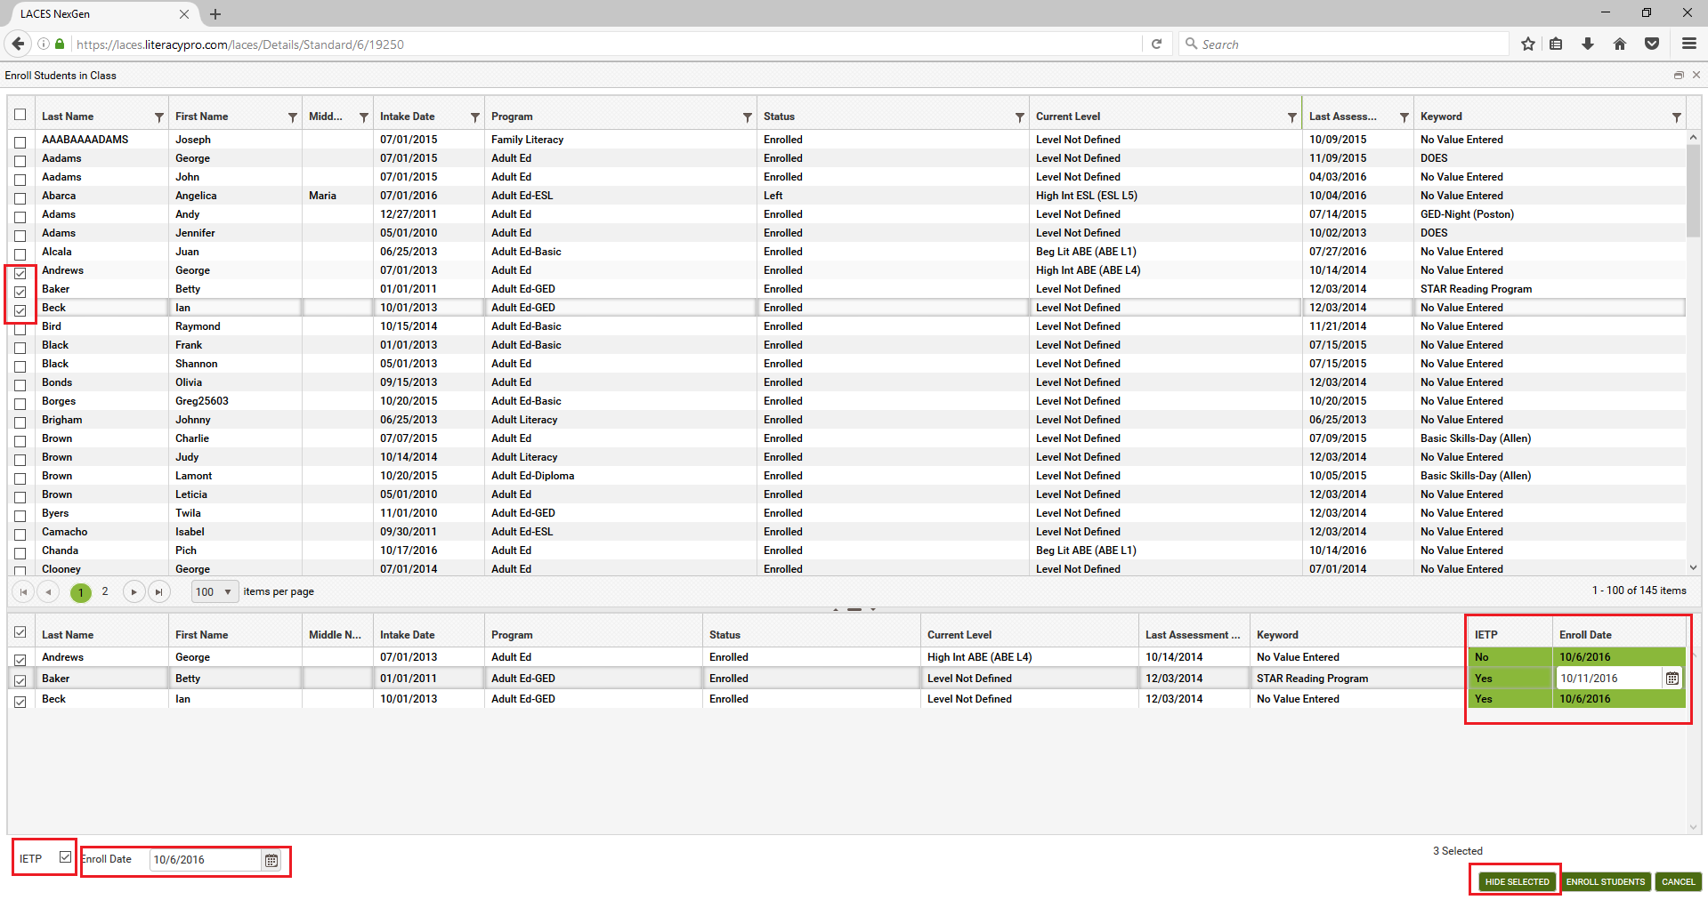

Make changes, if needed, and click the Enroll Students button to enroll the selected students when finished.

To enroll students in an IETP after they were already enrolled in the class without the IETP indicator:

If you need to update the IETP checkbox at any point to indicate IETP enrollment for a student, open the class record in which the student is enrolled. Double click the student’s enrollment record in the class, or click the Edit (eye) icon. In the Edit Enrollment window, locate the IETP checkbox in the right-hand column. Check or uncheck, as appropriate, and save. You cannot currently update IETP as a batch.

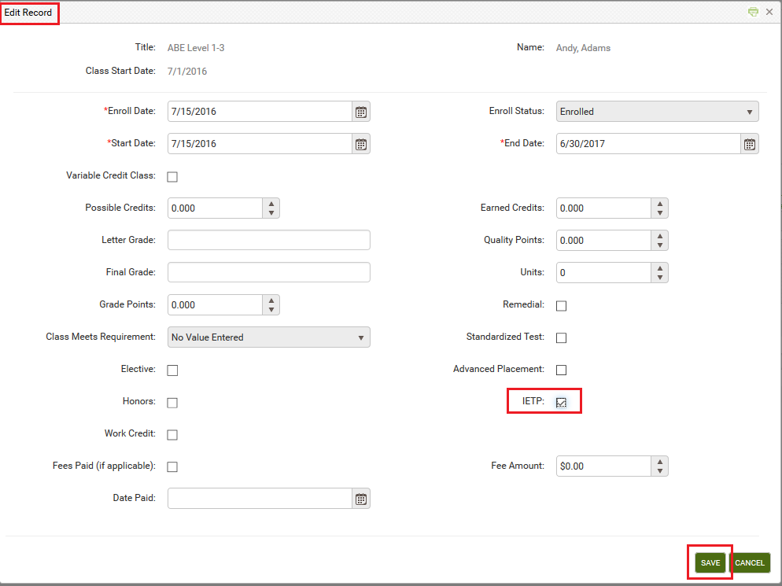

To view the IETP indicator for all students in a class:

In the Class Enrollment tab, change the View from the default Enrollment Info to Grades. This view displays a column for IETP, allowing you to view the IETP indicator for all students in the class at once.

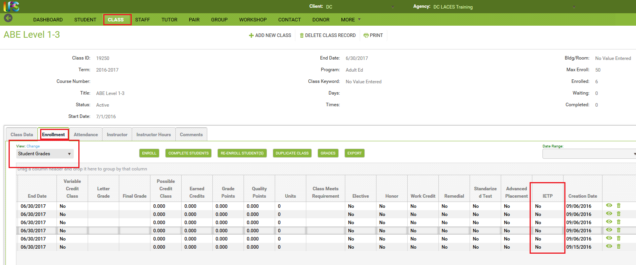

Any exited NRS participant student with an IETP indicator will automatically populate Column B of Table 5 for the Attainment of a Postsecondary credential outcome.

You can read additional information related to WIOA changes here: https://sites.google.com/a/literacypro.com/wioa-laces-updates/
Table 4
Measurable Skills Gains by Entry Level

To be a participant, students must have 12 or more hours in the fiscal year, with at least one qualifying period of participation, and be 16 years of age or older at the time of intake (note that some states have higher age requirements for admission). The total on Table 4 column B should match the totals for Tables 1, 2, and 3, as well as the sums for the rows/columns for Employment Status and Highest Education Level at Entry/Location on Table 6. Table 4 is period of participation based.
A Period of Participation (PoP) begins when a student enters your program and has 12 or more instructional hours, and ends when the student exits, as demonstrated by not having additional activity 90+ days after the last activity date. It is considered a new entry if the student returns in the current program year after a gap of 90+ days since the last activity. At that time a new PoP will begin. While it is possible for a student to have up to four PoPs within a fiscal year, most students will have one or two.
Columns B-H (except C) display only the data from the first period of participation for each NRS participant. Columns I-K display the summary data from all periods of participation for each NRS participant.
Column B displays the total number of enrolled NRS participants in each entry Educational Functioning Level. Entering Educational Functioning Level is set based on the tracked subject area pre-test for the first period of participation. Assessments are entered in the Assessment panel. Verify that the student has a “Pre” indicator for PoP1 in the Assessment panel. The row in which the “Pre” indicator displays for Pop1 is the subject area in which the student is being tracked for the first period of participation and what is used for population of the EFL for Table 4.
Column C displays the total number of instructional attendance hours accumulated in the fiscal year for all students populating Column B for that row. Column C does not include ancillary hours.
Column D displays the total number of participants who have achieved an educational functioning level gain in their first period of participation for that entry EFL. Gains in this column are calculated based on assessment or entry in post-secondary enrollment. Students only receive credit for the most recent gain (from either Column D or E) in a period of participation and do not receive additional credit for more than one gain in a PoP.

For a gain based on assessment, the pre-test subject area for the period of participation and the post-test in the same subject area in the same period of participation must result in a scaled score or GLE increase sufficient to demonstrate a gain in the entry EFL to a higher EFL. Assessment data is entered I the Assessments panel. EFL gains must be made within the fiscal year and within the period of participation. You can verify a gain by looking at the Pre and Post indicators in the Assessment panel and seeing an increase in EFL, or by looking in the Outcomes panel>PoP Summary/Measurable Outcomes tab and seeing “Yes” in either the EFL Gain (MSG) or Enrolled in PS Ed/Trng (MSG) column.

For a gain based on enrollment in post-secondary education or training, evidence of enrollment must be entered in the Education tab>Postsecondary Education or Training panel. Entry into Postsecondary Education or Training must occur after exit and on or before the current fiscal year end in order to qualify as a measurable skills gain for Table 4.

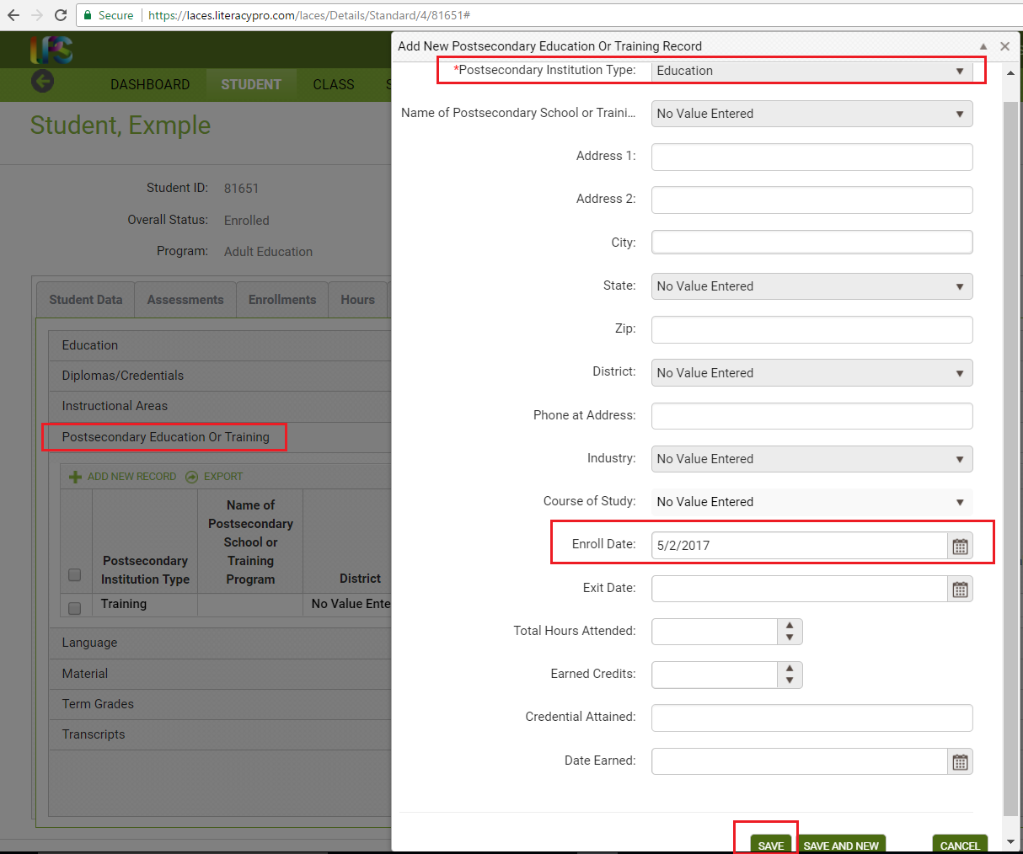
From the student record, go to Education>Postsecondary Education or Training panel. Click +Add New Record and enter the required Postsecondary Institution Type (Education or Training) and the Enroll Date (required), then Save. Other fields can be entered, if desired but the Type and Enroll Date are required.
You can search for students completing a gain in Column D by going to the student grid>Current FY Students and clicking Searches>NRS>NRS Table 4>click the total number at the bottom of Column D.
You can also search for students completing a gain in Column D by going to the student grid>Current FY Students> +Add Search option. From the +Add Search window, click the drop down arrow and scroll to the bottom. Click the triangle to the left of Student PoPs. Select Enrolled PS Ed/Trng (MSG) = checked box (click the box to check it, indicating Yes). Then click the + box at the end of the row to add an additional search and click the drop down arrow and scroll to the bottom. Click the triangle to the left of Student PoPs. Select EFL Gain (MSG) = checked box (click the box to check it, indicating Yes). Click Apply. This will return all students who have had a gain in a period of participation through a gain in educational functioning level or through meeting the requirements for enrolled in post-secondary education or training.
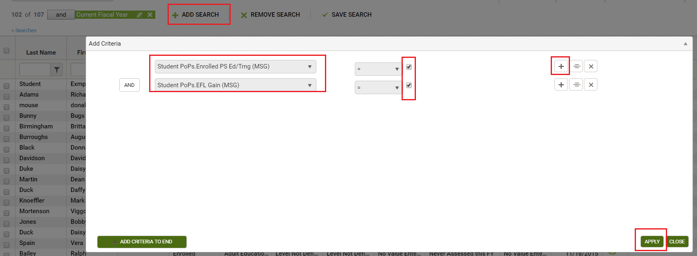
Column E displays the total number of participants who attained a secondary school diploma or its equivalent in the first period of participation for that entry EFL. Gains in this column are calculated based on evidence of attainment of a state and NRS approved secondary school credential or equivalent, such as a GED, HiSet, TASC, NEDP, or a state-approved high school equivalency exam/certificate. Although column E displays based only on the first period of participation, this outcome it typically retroactively tracked and counted even if it occurred in an additional period of participation because gains in this column are counted if the student attains the credential while enrolled or after exit if prior to the end of the fiscal year. Attainment of an HSE for Table 4 purposes must occur on or before fiscal year end. Passing of a single or multiple subject areas of a secondary school equivalency exam will not count as attainment; all subject areas need to be passed for credit to be given for this measurable skills gain. Completion of individual subtests of the SSD exams may be entered in the Assessment panel, if desired, but the gain will not be counted until all subject areas have been successfully passed and the credential attained. Students only receive credit for the most recent gain (from either Column D or E) in a period of participation and do not receive additional credit for more than one gain in a PoP.
Attainment of a secondary school diploma or its equivalent can be entered one of two ways.
- Scores can be entered in the Assessments tab, just as with any other assessment. Individual subject areas can be entered, if desired, but the gain will not be counted until all subject areas have been successfully passed and the credential attained.
- Indicator of attainment can also be entered in the Education tab>Diplomas/Credentials panel. From the student record, go to the Education tab>Diplomas/Credentials panel. Click +Add New Record and enter the required Diploma/Credential Type from the drop-down menu and the Date Earned (required), then Save. Other fields can be entered, if desired but the Type and Date Earned are required.
You can verify a gain through attainment of a secondary school diploma/equivalent by looking in the Outcomes panel>PoP Summary/Measurable Outcomes tab and seeing “Yes” in Attained SSD (MSG) column.
You can search for students completing a gain in Column E by going to the student grid>Current FY Students and clicking Searches>NRS>NRS Table 4>click the total number at the bottom of Column E.
You can also search for students completing a gain in Column E by going to the student grid>Current FY Students> +Add Search option. From the +Add Search window, click the drop down arrow and scroll to the bottom. Click the triangle to the left of Student PoPs. Select Attained SSD (MSG) = checked box (click the box to check it, indicating Yes). Click Apply. This will return all students who have had a gain in a period of participation through attainment of a recognized secondary school diploma or its equivalent.
Column F displays the total number of participants who separated before achieving measurable skills gains in the first period of participation for that entry EFL. Any student who did not have a measurable skills gain in the first period of participation and exited, through having no services/instructional hours for a 90+ day period, will be displayed in Column F. All forms of Measurable Skills Gains are tracked, so a student displayed here did not have a gain through EFL gain, attainment of a secondary school diploma or its equivalent, or enrollment in post-secondary education or training in their first period of participation.
Column G displays the total number of participants who are remaining in program without achieving measurable skills gains in the first period of participation for that entry EFL. Any student who did not have a measurable skills gain in the first period of participation but is still enrolled and/or is exited but does not have a gap in services/instructional hours for a 90+ day period, will be displayed in Column G. All forms of Measurable Skills Gains are tracked, so a student displayed here did not have a gain through EFL gain, attainment of a secondary school diploma or its equivalent, or enrollment in post-secondary education or training in their first period of participation.
The sum of Columns D + E + F + G should equal the total in Column B.
Column H displays the Percentage Achieving Measurable Skills Gains for the first period of participation for that entry EFL. The percentage is calculated by (Columns D + E)/Column B.
Column I displays the Total Number of Periods of Participation in the fiscal year for all NRS participants included in Column B. A participant may have more than one period of participation, and begins a new period of participation anytime they return and earn 12 or more hours after having had an initial qualifying period of participation followed by a gap of 90 or more days in instruction or services.
Column J displays the Total Number of Periods of Participation with Measurable Skills Gains in the fiscal year for all NRS participants included in Column B. The same Measurable Skills Gains tracked in Columns D and E qualify, but this column summarizes gains made in any period of participation rather than only the first period of participation. Multiple measurable skills gains are allowed for participants with more than one period of participation, however, only one gain per PoP can be reported in Column J.
Column K displays the Percentage of Periods of Participation with Measurable Skills Gains in the fiscal year for all NRS participants included in Column B. The percentage is calculated by Column J/Column I.

Current NRS Table | Change | New NRS Table
Table 4: Measurable Skill Gain and Attendance by Educational Functioning Level | 1. EFL gain expanded to be Measurable Skill Gain, defined as:  a) EFL gain by pre- and post-testing in the same subject area  b) completion of Carnegie Units  c) after exit from an ABE/ASE program, entry into postsecondary education or training within the program year  d) attainment of a secondary credential or equivalent within the program year  2. Column for completed and advanced no longer reported and therefore removed from table  3. New columns (I, J, K) added for period of participation reporting  4. Columns B-H, excluding column C only report the data obtained for the first period of participation. Column C displays attendance hours for the full fiscal year. | Table 4: Measurable Skill by Entry Level

Impact on your data entry:
1. EFL gain expanded to be Measurable Skill Gain (MSG), defined as:
a) EFL gain by pre- and post-testing in the same subject area: LACES will continue to track pre- and post-assessment and calculate gains. The potential for data entry impact will be related to what is considered a pre-test and what is considered a post-test within separate periods of participation.
To understand assessments with relation to periods of participation, it is necessary to understand what a period of participation is, and how the order in which hours, enrollments, and assessment dates are entered can impact this data.
A Period of Participation (PoP) begins when a student enters your program and has activity, and ends when the student leaves, or does not have additional activity 90+ days after the last activity date. It is considered a new entry if the student returns in the current program year after a gap of 90+ days since the last activity. At that time a new PoP will begin. While it is possible for a student to have up to four PoPs within a fiscal year, most students will have one or two.
A read only PoP summary record will populate at the Outcomes tab/PoP Summary/Measurable Outcomes panel once a level defining pre-test AND 12 instruction hours have been entered in the student record. Students do not count on NRS Table 4 until they have at least one PoP. (Please refer to the Table 4 https://sites.google.com/a/literacypro.com/wioa-laces-updates/home instructions link)
A student does not count as an NRS participant if they do not have a period of participation within the fiscal year. It is possible for a student to have 12+ hours in a Fiscal Year, but have 90 gaps between hours that prevent them from having a PoP.

Students can have a PoP that crosses the fiscal year, resulting in them counting on the NRS tables in both years, even if they did not have 12+ hours in the second fiscal year. For example, if a student attends with 12+ hours and a valid EFL from 2-11-17 until 7-5-17 and then exits without earning 12+ hours in 17/18, their period of participation crosses the fiscal year and they would still populate the 17/18 NRS tables even though they did not have 12+ hours in 17/18.
All student data has been synced to a PoP. This means that students who meet the requirements to be in a PoP will display a record(s) at the student Outcomes tab/PoP Summary/Measurable Outcomes panel.
Each PoP summary record will display:
- A start date
- An end date
- Total number of instruction hours in the PoP
- Subject area
- Entry level
- Exit level
- Completed Level
- Obtained Secondary Credential (based on an assessment record or a diploma info record)
- Entered Postsecondary Education (based on a Postsecondary Education or Training record)
- Left Date
IMPORTANT NOTE: Employment information will (likely) be included in the PoP summary record in a future release.
How PoP Data is Calculated

PoP Start Date | First activity in a PoP:  - First assessment date, whether a level defining assessment or not  - First hours date, regardless of hours type  - The student start date in a class, group, or workshop, or pair match date  - Diploma/Credential record date earned
PoP End Date | Last activity in a PoP:  - Most recent assessment date, whether level defining assessment or not  - Last hours, regardless of hours type  - Most recent start date in a class, group, or workshop, or pair match date if there are not hours entered after that date within 90+ days
Instruct Hours | - The total number of instructional hours between the PoP start and end date. (Remember that an hours date may also be used to calculate the PoP start or end date.)
Subject Area | - The subject area of the assessment in effect between the Pop start and end date. (Remember that an assessment date may also be used to calculate the PoP start or end date.)
Entry Level | - The entry level based on the level defining assessment identified as the pretest in the PoP.
Exit Level | - The exit level based on the assessment identified as the post test in the PoP, or the level of the assessment identified as the pretest if no post test has been entered.
Left Date | - Left date in the PoP. This date will not display until 90 days after the last activity in a PoP, but will be based on the left date rules.
Enrolled PS Education/Training  (MSG) (measurable skills gain) | - Displays 'yes' if the student entered postsecondary education after the exit date in the PoP and the PoP left date displays. Entered Postsecondary Education and Training records are entered in the student record at the Education tab>Postsecondary Education or Training panel.
EFL Gain (MSG) | - Displays 'yes' if level is completed from a post test in the tracked subject area for the PoP.  - Displays 'yes' if entry level is ABE L6 and the student earns a secondary school diploma.  - Displays 'yes' if the student entered Postsecondary education or training after PoP exit date but before the last day of the fiscal year. NOTE: Entered Postsecondary after exit now counts as an EFL gain on Table 4: (click for further info): https://sites.google.com/a/literacypro.com/wioa-laces-updates/home.
Attained SSD (MSG) | - Displays 'yes' if the student earned a secondary credential. Attainment of a secondary school diploma/credential can be entered in the student record at the Assessments tab or at the Education tab>Diploma/Credentials panel with the Type and Date Earned entered.

In the screenshot below:
- The student's first enrollment was on 7/5/2016, which set the PoP start date.
- The last instruction hours were on 7/14/2016, which set the PoP end date.
- There was a total of 14 instructional hours in the PoP.
- The student's assessment subject was Read.
- The assessed entry level was ABE L5.
- The student did not have a post test, so the exit level was also ABE L5.
- Completed Level is 'yes' because the student Entered Postsecondary Education after the PoP exit date but before the end of the fiscal year. Entering Postsecondary after PoP exit may now count as an EFL gain on Table 4.
- Obtained Secondary Credential is 'yes' because the student earned a GED.
- Left Date is 7/14/2016, which is the date of the last instruction hours.
- Entered Postsecondary Education is 'yes' because the student has a Postsecondary Education record entered after the end date of the PoP but before the last day of the fiscal year.

REMEMBER: A new PoP will not begin until there is activity 90+ days after the previous PoP end date. A PoP summary record will not populate until an assessment and 12+ instruction hours have been entered.
Q: A student in my program has had an assessment, is enrolled in a class, and has hours, but doesn't have a PoP Summary/Measurable Outcome record. Why not?
A: In order for a PoP Summary/Measurable Outcomes record to populate, the student must have at least 12 instructional hours without a gap. For example, look at the screenshot below.
Even though this student has been assessed and is enrolled, the student did not earn at least 12 hours before a 90 day gap in activity. The student earned 4.75 hours between 8/31/2016 and 11/11/2016. There is a 90+ day gap between the hours on 11/11/2016 and 2/24/2017. The student still has not earned at least 12 instructional hours after the gap, so will not have a PoP record until at least 2 more instructional hours are earned within 90 days of 3/3/2017.
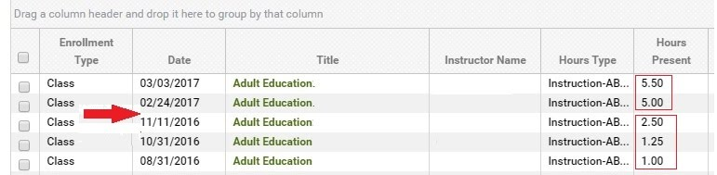

Assessments in PoPs
You will notice additional columns on the Student Assessments grid at the Pre/Post default view.
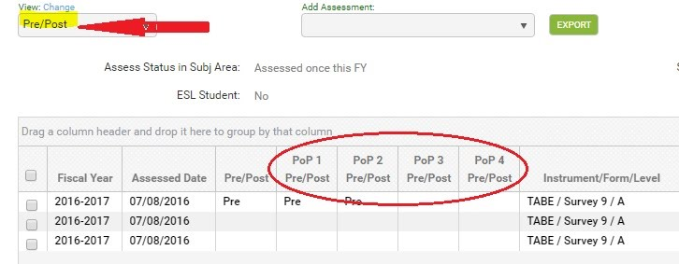

The additional columns allow you to see the assessments being used as the pre and post tests within a PoP.
There are four PoP Pre/Post columns because it is possible for a student to enter your program 4 times within the program year with 90+ day gaps.
It is important to understand what displays on the assessment grid and how the information pertains to the student's assessment activities. Hours and assessment dates are VITALLY IMPORTANT for determining if an entered assessment is a pre or post assessment in a new PoP, please read thoroughly!
Pre/Post Column | The Pre/Post column identifies the assessments being used as the pre and post tests for the entire program year. The assessments in this column populate the student header 'Subject Area', 'Entry Level', and 'Current Level' fields. This is exactly what LACES has always done, so there is NO CHANGE to this functionality.  This column and functionality was not changed since many independent literacy agencies who also use LACES do not report to the NRS, and their additional reporting needs may not include PoPs.  Important: Depending on whether or not a subject area override has been indicated, an assessment that shows as the pretest in this column may not be the pretest for the first PoP. This is explained in further detail below for Assessment Rule 1.
Pop 1, PoP 2, PoP 3, PoP 4 Pre/Post Columns | These columns identify the assessments being used as the pre and post tests for each student program entry that starts a new PoP.  There are specific rules that are used to identify existing assessments as the pre or post test in a PoP, or to determine the pretest or subject area in a PoP when a new assessment is entered. See the rules below.

Assessment Rules
- The most recent assessment in the subject area is carried forward as the pretest for the next PoP after a 90+ day gap in activity, regardless of scaled score or SPL/GLE.
- The user may override the carried forward assessment by selecting a different subject area in the previous PoP. The most recent assessment in the subject area, however, will be used as the pretest in the new PoP.
- A level defining assessment, regardless of subject area, entered before the first hours date after the start of a PoP will override the automatically carried forward assessment.
- An assessment in the subject area entered AFTER the first hours date in a PoP will be considered to be the post test when there is a carried forward pretest.
- Any assessment in a different subject area entered AFTER the first hours date in the PoP can be set as the subject area in the PoP, overriding the default subject area.

To enter Postsecondary Education or Training, open the student record. Go to the Education tab, Postsecondary Education or Training panel, and click to expand the panel:

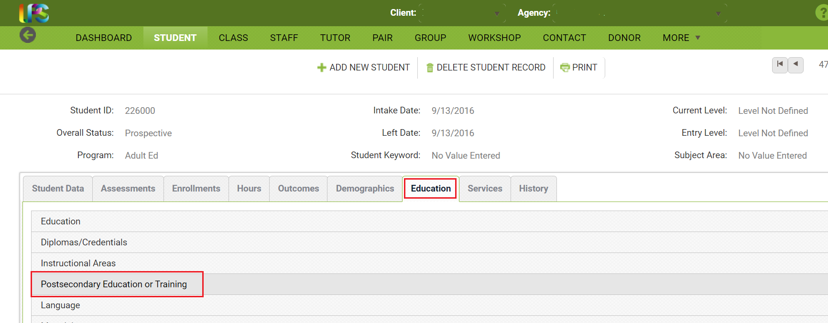
Once the panel is expanded, click the Add New Item + link. In the pop-up window, enter the Postsecondary Institution Type (Education or Training) and the Entry Date. Entry Date is required, despite lacking the red asterisk. Other fields may be entered, if desired but are not required.
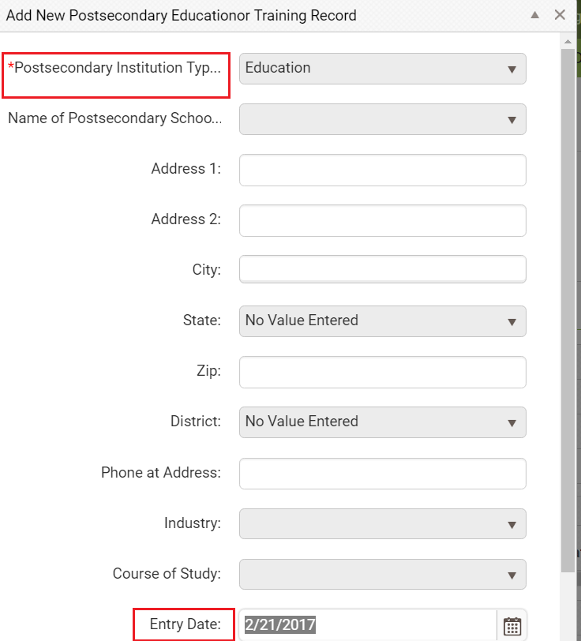
d) attainment of a secondary credential or equivalent: No impact to your data entry process. This will continue to be tracked based on evidence of completion of a secondary school credential or equivalent through entry into the Assessments tab, entry of a qualifying credential in the Diploma/Credential panel of the Education tab, or data match by the state, if applicable.
Secondary school credentials are GED, TASC, HiSet, state-approved high school equivalency exams, and NEDP. These may be entered as a record at the student Education tab>Diplomas/Credentials panel with the Diploma/Credential Type selected, and the Date Earned entered, or by entering the assessment scores in the Assessment tab.
There are three changes in the way secondary credentials are reported on NRS Table 4.
- Obtaining a secondary credential is not counted as a completed level when the student's entry level is ABE L6, as it was previously on Table 4. Now, obtaining a secondary credential counts on the new Table 4 in column E (Attaining a secondary school diploma or its equivalent.)
- Students do not have to enter at ABE L6 in order to count on Table 4 as attaining a secondary credential.
- Table 4b no longer has a row for ABE L6 to show completed level when a student attains a secondary credential.
2. Column for completed and advanced no longer reported and therefore removed from table: No impact on your data entry
3. New columns (I, J, K) added for period of participation reporting:
Periods of participation track students who exit the program for 90 days or more and have no scheduled services and then return to the program.
A student is considered to have entered their first period of participation upon enrollment for the fiscal year and attainment of 12 or more hours with a valid entry Educational Functioning Level. (Note that beginning in FY 17/18, there will be new tables that will track “NRS Reportables”- students with less than 12 hours in the fiscal year and a valid entry Educational Functioning Level. Once this is implemented, a period of participation will begin at the time of enrollment for the fiscal year regardless of number of hours, with the number of hours determining if the student is a reportable (<12 hours) or participant (>12 hours) for the period of participation.)
Students can have multiple periods of participation in a fiscal year. A new assessment should be administered OR the appropriate assessment from the prior period can be used for each new period of participation, based on your state’s assessment policy. Barriers to employment should be updated each new period of participation if they have changed from the last period of participation.
Participants cannot be determined to have exited the program until at least 90 days have elapsed since their last hour’s date.
Multiple outcomes are reported for students with more than one period of participation, with a maximum of one gain per period reported in column J. If a student achieves multiple MSG’s in one period of participation, only the most recent should be reported on Table 4.
4. Columns B-H (excluding C) only report the data obtained for the first period of participation: You will continue to enter in all known information about the student, paying particular attention to accurate data entry for hours in order to insure students do not inadvertently show as exited if they should not be. LACES will determine the accurate periods of participation and measurable skill gains and report them in the correct columns based on the federal guidelines.

You can read additional information related to WIOA changes here: https://sites.google.com/a/literacypro.com/wioa-laces-updates/
Table 4B
Educational Functioning Level Gain and Attendance for Pre- and Post-Tested Participants

To be a participant, students must have 12 or more hours in the fiscal year, with at least one qualifying period of participation, and be 16 years of age or older at the time of intake (note that some states have higher age requirements for admission). To display on Table 4B, a participant must have had a valid pre-test followed by a valid post-test in the tracked subject area, within the fiscal year. Table 4B totals generally do not match the other NRS Table totals. Table 4B is fiscal year based.

Column B displays the total number of enrolled NRS participants with both a pre- and post-test in their tracked subject area in each entry Educational Functioning Level. Entering Educational Functioning Level is set based on the tracked subject area pre-test for the first period of participation. Assessments are entered in the Assessment panel. Verify that the student has a “Pre” indicator for PoP1 in the Assessment panel. The row in which the “Pre” indicator displays for Pop1 is the subject area in which the student is being tracked for the first period of participation and what is used for population of the EFL for Table 4B. Students must additionally have a valid post-test within the same subject area as the indicated pre-test.
The assessment administered as the pre-test must be a valid, state and OCTAE approved assessment resulting in a valid Educational Functioning Level. Students who enter as Completed Advanced ESL cannot be counted on the NRS tables and should be re-assessed.
Column C displays the total number of instructional attendance hours accumulated in the fiscal year for all students populating Column B for that row. Column C does not include ancillary hours.
Column D displays the total number of pre- and post-tested NRS participants with an EFL Gain in the fiscal year for each entry educational functioning level. This table only tracks gains made from Educational Functioning Level gain through pre-and post-testing and does not calculate measurable skills gains made from enrolling into postsecondary education or training or attainment of a secondary school diploma or its equivalent.
Column E tracks the total Number Separated Before Achieving EFL Gain in the fiscal year for each entry educational functioning level. Any student who did not have a level gain in fiscal year and exited, through having no services/instructional hours for a 90+ day period, will be displayed in Column E. This table only tracks gains made from Educational Functioning Level gain through pre-and post-testing and does not calculate measurable skills gains made from enrolling into postsecondary education or training or attainment of a secondary school diploma or its equivalent.
Column F tracks the total Number Remaining Within Level in the fiscal year for each entry educational functioning level. Any student who did not have a level gain in the fiscal year but is still enrolled and/or is exited but does not have a gap in services/instructional hours for a 90+ day period, will be displayed in Column F.
Column G displays the Percentage Achieving EFL Gains for the fiscal year for that entry EFL. The percentage is calculated by Columns D/Column B.

Table 4C
Measurable Skills Gains by Entry Level for Participants in Distance Education

Table 4C is basically Table 4, but only tracks participants for whom the majority of their instructional hours were generated through distance learning.

Distance Learning is tracked if the hours entered for a student are indicated as Instruction-Distance Learning. If 51% or more of a student’s Current FY Instructional Hours were generated from Distance Learning, then the student will populate all NRS tables and additionally populate 4C and 5A, which are tables specifically used for tracking Distance Learning.

All columns use the same rules and logic as Table 4, but are only populated with students who qualify as Distance Learning participants.

Table 5
Core Follow-up Outcome Achievement

Table 5 tracks outcome achievements for exited NRS participants. The collection periods for outcomes varies by outcome, and employment outcomes have specific follow-up periods.

OCTAE will not be collecting Table 5 or its variations (Tables 5a, 8, and 10) for 16/17, and the tables will therefore display no data.

Column A displays the specific core Follow-up Outcome Measures being tracked. Column B displays the Number of Participants who Exited who should be tracked for that outcome.

Columns B-D will populate based on the first period of participation only, the same as Table 4. Columns E-G will populate based on a summary of all periods of participation.

Students in Corrections education will not populate outcomes on Table 5.

Measure Definitions, Collection Method, and Number Reported information for Table 5 are as follows:

Measure | Participants to Include (Column B) | Definition | Participants in Column C (Met)
Employment in 2nd quarter after exit | All NRS participants, except those incarcerated at program entry and who remain incarcerated, who exit during the reporting period | Employment status in second quarter after exit | Number of students from column B who are employed
Employment in 4th quarter after exit | All NRS participants, except those incarcerated at program entry and who remain incarcerated, who exit during the reporting period | Employment status in fourth quarter after exit | Number of students from column B who are employed
Median Earnings, 2nd quarter | All NRS participants who exit during the reporting period and who are employed in the 2nd quarter after exit | Midpoint of wages between lowest and highest wage in the 2nd quarter after exit | Median wage (midpoint of wages between lowest and highest wage)
Obtained a Secondary School Credential & Enrolled in PS Education/Training w/in one year | All NRS participants, except those incarcerated at program entry and who remain incarcerated, who exit during the program year and who were at a 9th grade equivalent educational functioning level or higher (Low and High Adult Secondary), at entry or exit, as measured by assessment with an approved NRS test | Receipt of a state-recognized secondary credential or diploma during participation or w/in one year after exit and enrollment in postsecondary education or training within one year after exit | Number of students from column B with a secondary credential who are enrolled in postsecondary education or training within one year after exit
Obtained a Secondary School Credential & Employed w/in one year | All NRS participants, except those incarcerated at program entry and who remain incarcerated, who exit during the program year and who were at a 9th grade equivalent educational functioning level or higher (Low and High Adult Secondary) at entry or exit, as measured by assessment with an approved NRS test | Receipt of a state-recognized secondary credential or diploma during participation or w/in one year after exit and obtained employment within one year after exit | Number of students from column B with a secondary credential who are employed within one year after exit
Attained a Postsecondary Credential w/in one year | All NRS participants enrolled in an IETP or joint adult ed/post-secondary education program who exit during the program year | Receipt of a state-recognized postsecondary credential during participation or w/in one year after exit | Number of students from column B with a postsecondary credential earned during participation or within one year after exit

The easiest way to know if the Outcome Measures are being correctly tracked is to view the Outcomes tab>PoP Summary/Measurable Outcomes panel. Table 5 is an Outcome Measure table and therefore only tracks measures for exited students, so the Measurable Outcomes data will not populate in the summary until the student is exited (without hours or services in 90+ days). Please review the PoP Summary/Measurable Outcomes explanations below.

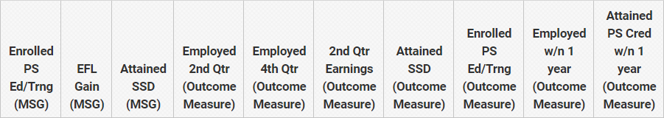

Enrolled PS Ed/Trng (MSG) | Collected for Table 4 purposes and tracking, not used for Table 5
EFL Gain (MSG) | Collected for Table 4 purposes and tracking, not used for Table 5
Attained SSD (MSG) | Collected for Table 4 purposes and tracking, not used for Table 5
Employed 2nd Qtr (Outcome Measure) | Populated based on the Work History panel of the History tab in the student record.  - Follow-up is done for all NRS students except Corrections (incarcerated), regardless of employment status  - Follow-up can be done via state data match -OR- manual survey. There is no longer a required 50% response rate for surveys.  - We strongly recommend adding a new line of work history for each follow-up conducted, even if the employment status remains the same. The follow-up should be done in the correct quarter and the start date should indicate the date of follow-up.  - Enter earnings into the Earnings field and complete the Earnings Period and Number of Hours so that LACES can populate the Quarterly Earnings. Do not use the Salary field, as that is not the field used for Table 5.  - Follow-up should be done the 2nd and 4th quarter for EACH period of participation
Employed 4th Qtr (Outcome Measure) | Populated based on the Work History panel of the History tab in the student record.  - Follow-up is done for all NRS students except Corrections (incarcerated), regardless of employment status  - Follow-up can be done via state data match -OR- manual survey. There is no longer a required 50% response rate for surveys.  - We strongly recommend adding a new line of work history for each follow-up conducted, even if the employment status remains the same. The follow-up should be done in the correct quarter and the start date should indicate the date of follow-up.  - Enter earnings into the Earnings field and complete the Earnings Period and Number of Hours so that LACES can populate the Quarterly Earnings. Do not use the Salary field, as that is not the field used for Table 5.  - Follow-up should be done the 2nd and 4th quarter for EACH period of participation
2nd Qrt Earnings (Outcome Measure) | Populated based on the Work History panel of the History tab in the student record.  - Follow-up is done for all NRS students except Corrections (incarcerated), regardless of employment status  - Follow-up can be done via state data match -OR- manual survey. There is no longer a required 50% response rate for surveys.  - We strongly recommend adding a new line of work history for each follow-up conducted, even if the employment status remains the same. The follow-up should be done in the correct quarter and the start date should indicate the date of follow-up.  - Enter earnings into the Earnings field and complete the Earnings Period and Number of Hours so that LACES can populate the Quarterly Earnings. Do not use the Salary field, as that is not the field used for Table 5.  - Follow-up should be done only for the 2nd quarter for EACH period of participation
Enrolled PS Ed/Trng (Outcome Measure) | Populated based on the Education tab>Postsecondary Education/Training panel and the Assessments panel OR Education tab>Diploma/Credentials panel  This is a combination outcome for students who both Attain their Secondary School Credential/Diploma AND then enter Postsecondary Education and Training for tracking on Table 5. Enrollment in PS Education or Training as its own outcome is only tracked on Table 4 as a measurable skills gain effective 16/17.  This outcome is only tracked for exited NRS participants who were at a 9th grade level equivalency or higher in the FY in which they exited.  To indicate enrollment in a PS Education or Training, from the individual student record, go to the Education tab>Postsecondary Education or Training panel. Click +Add New record and indicate the Type of Postsecondary Institution (education or training) and the Date Enrolled, then save.
Attained SSD (Outcome Measure) | Populated based on the Assessments panel OR Education tab>Diploma/Credentials panel and the Education tab>Postsecondary Education/Training panel or History tab>Work History panel  This is a combination outcome for students who both Attain their Secondary School Credential/Diploma AND either enter Postsecondary Education and Training or Enter Employment for tracking on Table 5. Attainment of a secondary school credential/diploma as its own outcome is only tracked on Table 4 as a measurable skills gain effective 16/17.  This outcome is only tracked for exited NRS participants who were at a 9th grade level equivalency or higher in the FY in which they exited.  To indicate attainment of an SSD from the individual student record, go to the Education tab>Diploma/Credential panel. Click +Add New record and indicate the Type of SSD (GED, TASC or HiSet) and the Date Earned, then save.  This outcome is additionally used to track the combined outcome of Attained a SSD and Employed within one year of exit, using this indicator with the Work History data for eligible students.
Attained PS Credential w/n 1 year (Outcome Measure) | Populated based on the Education tab>Postsecondary Education/Training panel (Type+ Enrolled Date+Credential Attained + Date Earned)  This outcome is populated only for students who were enrolled in an IETP program as indicated on Table 3. Completion/attainment is indicated by:  - Entered a Postsecondary Type (education or training) AND Credential Attained AND Enrolled Date AND Date Earned (must be after Enrolled Date) in the Education tab>Postsecondary Education/Training panel

Employment Measure Follow up Quarters: Currently, the dashboard and searches display the old method of employment follow-up (first and third quarters). We will be updating LACES to display the new follow-up quarters on the dashboard and searches, but the chart below should be helpful until we can update those features.
If the student exited: | Their Follow-Up Should be Done: | In this Date Range | And will populate in this Fiscal Year’s Table 5:
7/1/16 to 9/30/16 | 2nd Quarter Follow up should be done | 1/1/17 to 3/31/17 | NRS Table 5 2017-2018
 | 4th Quarter Follow up should be done | 7/1/17 to 9/30/17 | NRS Table 5 2017-2018
10/1/16 to 12/31/16 | 2nd Quarter Follow up should be done | 4/1/17 to 6/30/17 | NRS Table 5 2017-2018
 | 4th Quarter Follow up should be done | 10/1/17 to 12/31/17 | NRS Table 5 2017-2018
1/1/17 to 3/31/17 | 2nd Quarter Follow up should be done | 7/1/17 to 9/30/17 | NRS Table 5 2017-2018
 | 4th Quarter Follow up should be done | 1/1/18 to 3/31/18  (Third Quarter) | NRS Table 5 2018-2019
4/1/17 to 6/30/17 | 2nd Quarter Follow up should be done | 10/1/17 to 12/31/17 | NRS Table 5 2017-2018
 | 4th Quarter Follow up should be done | 4/1/18 to 6/30/18 | NRS Table 5 2018-2019

You can read additional information related to WIOA changes here: https://sites.google.com/a/literacypro.com/wioa-laces-updates/
Table 5a
Outcome Achievement for Participants in Distance Education

Table 5a is basically Table 5, but only tracks participants for whom the majority of their instructional hours were generated through distance learning.

Distance Learning is tracked if the hours entered for a student are indicated as Instruction-Distance Learning. If 51% or more of a student’s Current FY Instructional Hours were generated from Distance Learning, then the student will populate all NRS tables and additionally populate 4C and 5A, which are tables specifically used for tracking Distance Learning.

All columns use the same rules and logic as Table 5, but are only populated with students who qualify as Distance Learning participants.

Table 6
Participant Status and Program Enrollment

To be a participant, students must have 12 or more hours in the fiscal year, with at least one qualifying period of participation, and be 16 years of age or older at the time of intake (note that some states have higher age requirements for admission). The totals on Table 6 for Employment Status sum and the sum of the Highest Degree or Level of School Completed/Location rows and columns should match the totals for Tables 1, 2, 3, and 4. Table 6 is fiscal year based.
A Period of Participation (PoP) begins when a student enters your program and has 12 or more instructional hours, and ends when the student exits, as demonstrated by not having additional activity 90+ days after the last activity date. It is considered a new entry if the student returns in the current program year after a gap of 90+ days since the last activity. At that time a new PoP will begin. While it is possible for a student to have up to four PoPs within a fiscal year, most students will have one or two.
Column A tracks the participant status at Program Entry based on:
- Employment Status: Populates based on Employment Status from the History tab>Work History panel in the student record. Employment status is set at Intake on the Intake Form but can be updated in the History tab>Work History panel in the student record. Population to Table 6 is based on the Employment Status at the time of the data freeze.
  - Employed indicates that the participant, at program entry, is either a) currently performing any work at all as a paid employee, b) is currently performing any work at all in his or her own business, profession, or farm, c) is currently performing any work as an unpaid worker in an enterprise operated by a member of the family, or d) is one who is not working but currently has a job or business from which he or she is temporarily absent because of illness, bad weather, vacation, labor-management dispute, or personal reasons, whether or not paid by the employer for time off and whether or not seeing another job.
  - Employed but Received Notice of Termination of Employment or Military Separation is Pending indicates that the student is currently employed but has received notice of termination of employment or the employer had issued a Worker Adjustment and Retraining Notification (WARN) or other notice that the facility of enterprise will close or is a transitioning service member (ie, within 12 months of separation or 24 months of retirement from the military.
  - Unemployed indicates that the student is currently not working but is actively seeking employment and is therefore still part of the labor force.
  - Not in the Labor Force covers the statuses of Retired, Not Looking for Work, and Unavailable for Work and indicates that the student is currently not employed and is not actively seeking employment and does not intend to be part of the labor force.
  - Employment status should be correctly collected and entered into LACES regardless of the presence or absence of a student Social Security Number.
  - Invalid or Missing Employment Statuses can be located by running a Student Diagnostic Search on all NRS Fundable or Current FY Students and viewing the total in the row for Search for Students with Incorrect or Missing Employment Status. Manually run FY Summaries or schedule FY Summaries to be run and then run this search when the summaries are updated. To run the search, go to the student grid. Searches>NRS>(either)Current Fiscal Year OR NRS Fundables>Add. Then Student Diagnostic Search>Add. View total in the row for Search for Students with Incorrect or Missing Employment Status. Click the number and correct in the History tab>Work History panel.

- Highest Degree or Level of School Completed: Populates based on the Highest Education Level Completed on Entry and Highest Education Level Completed on Entry Location fields from the Education tab>Education panel. Students entered prior to July 1, 2012 may be missing these fields as they did not become required until that date. Invalid or Missing Highest Education Statuses can be located by running a Student Diagnostic Search on all NRS Fundable or Current FY Students and viewing the total in the rows for Search for Students with Missing or Missing Educational Data. Manually run FY Summaries or schedule FY Summaries to be run and then run this search when the summaries are updated. To run the search, go to the student grid. Searches>NRS>(either)Current Fiscal Year OR NRS Fundables>Add. Then Student Diagnostic Search>Add. View the total in the rows for Search for Students with Missing or Missing Educational Data. Click the number and correct in the Education tab>Education panel.

- Program Type: Populates based on Program from the Student Data tab>Key Info panel in the student record. Program is set at Intake on the Intake Form but can be updated in the Student Data tab>Key Info panel in the student record. Population to Table 6 is based on the Program at the time of the data freeze. Participants counted here must be in a program specifically designed for the purposes states. Only the following special programs are tracked on Table 6; the primary programs are tracked on Table 3:
  - Family Literacy: The literacy program has a family learning component to it and is funded as such.
  - Workplace Adult Education and Literacy Activities: Adult education and literacy activities offered by an eligible provider in collaboration with an employer or employee organization at a workplace or an off-site location that is designed to improve the productivity of the workforce.

- Institutional Programs: Populates based on Correctional or Institutional from the Demographics tab>Demographics panel in the student record. Correctional or Institutional fields are set at Intake on the Intake Form but can be updated in the Demographics tab>Demographics panel in the student record. Population to Table 6 is based on the Correctional and Institutional fields at the time of the data freeze
  - In Correctional Facility: Any value in the Correctional field containing Yes
  - In Community Correctional Program: Yes-Community in the Correctional field
  - In Other Institutional Setting: Any value in the Institutional field containing Yes

You can read additional information related to WIOA changes here: https://sites.google.com/a/literacypro.com/wioa-laces-updates/
TABLE 7: No changes!

REMAINDER: Anticipated release prior to June 30 2017 unless otherwise noted
Current NRS Table | Change | New NRS Table
Table 8: Outcomes for Adults in Family Literacy Programs (optional table) | Identical to new Table 5 with a row added for Measurable Skill Gains; includes optional measures of increased involvement in children’s education and increased involvement in children’s literacy activities  Impact on your data entry: Will be tracked identically to Table 5 for any student with Family Literacy indicated as their Primary Program. Measurable skill gains will be tracked as they are on Table 4, but also counted on this tables for those students with the Family Literacy Program type.  Family literacy-specific outcomes are tracked through the family literacy goals entered through the Outcomes tab>Goals and Achievements panel | Table 8: Outcomes for Adults in Family Literacy Programs (optional table)
Current NRS Table | Change | New NRS Table
Table 9: Outcomes for Adults in Work-Based Project Learning Outcomes (optional table) | Eliminated Table 9, optional Work-Based Project Learner Outcome Table and replaced it with Secondary Outcomes Measures (Optional) -what used to be Table 11  Impact on your data entry: Will be tracked identically to the old Table 11- outcomes populate based on secondary goals entered through the Outcomes tab>Goals and Achievements panel | Table 9: Secondary Outcome Measures (Optional)
Current NRS Table | Change | New NRS Table
Table 10: Outcomes for Adults in Correctional Education Programs | Revised to be identical to new Table 5 with a row added for measurable skill gains; separate reporting of participants in correctional education programs  Corrections education is for criminal offenders (any individual who is charged with or convicted of any criminal offense) who reside in correctional institutions, including:  (A) prison;  (B) jail;  (C) reformatory;  (D) work farm;  (E) detention center; or  (F) halfway house, community-based rehabilitation center, or any other similar institution designed for the confinement or rehabilitation of criminal offenders  Other institutionalized individuals are not defined in WIOA, but examples might include persons who reside in facilities operated by a state mental health agency or individuals in civil confinement institutions.  Impact on your data entry: Will be tracked identically to Table 5 for any student with Corrections indicated as their Primary Program -or- a Yes indicator for any of the available Corrections drop-down menu options. Measurable skill gains will be tracked as they are on Table 4, but also counted on this tables for those students with the Corrections indicators. Students must exit the Correctional facility, not just the Adult ed program in the correctional facility, in order to populate Table 10 | Table 10: Outcome Achievement for Adults in Correctional Education Programs
Current NRS Table | Change | New NRS Table
Table 11: Secondary Outcome Measures (optional) | Eliminated Table 11, which became Table 8 | n/a
Table 12: Work-based Project Learner by Age, Ethnicity, and Sex (Gender) | Eliminated | n/a
Table 13: | Eliminated in 2012 | n/a
Table 14: Local Grantee by Funding Source | Columns added to include Integrated English Literacy and Civics Education providers  Impact on your data entry: None. LACES does not, and never has, populated Table 14. A template is provided for your convenience. | Table 14: Local Grantee by Funding Source

Joint Report | A new, collaborative report to be added for joint reporting between Title I and Title II programs. Most of the data required for Title II will be populated based on the NRS Tables. Required tracking of Barriers to Employment have been added for the Joint Report. | Joint Report

Impact on your data entry:

On the intake page:
- If the student has barriers to employment, select the Yes radio button at the required field “Does this person have barriers to employment?” This field is ONLY on the intake form.
- You must check at least one field before the intake form can be saved if you select “Yes.”
- If the student does not have barriers to employment, check No. You may save the intake form when No is checked, whether any barriers to employment fields are checked or not.

In the History tab>Barriers to Employment panel:
- You can edit the Barriers to Employment for existing students in the History tab>Barriers to Employment panel
- Barriers to Employment should be updated after any 90+ day gap followed by a return

The barriers to employment fields are:
- Cultural Barriers
- Disabled
- Displaced Homemaker
- Economic Disadvantage
- English Language Learner
- Ex Offender
- Exiting TANF Within Two Years
- Foster Care Youth
- Homeless
- Long Term Unemployed
- Low Literacy Levels
- Migrant Farmworker
- Seasonal Farmworker
- Single Parent or Guardian

Definitions of the Barriers to Employment should be obtained through your state office, as they can vary by state. Barriers are self-reported and can also be observed.

New Left Date Rules
How a student's left date is calculated has not changed. The left date calculates and displays in the student record header in the Left Date field based on:
- Student's last instruction hours date, including unlinked instruction hours. (Records with 0 hours do not count.)
- Student's last class or group start date, or pair match date if the student was enrolled or matched in a pair, but no instruction hours were entered.
- Student's intake date if there are no enrollments or hours.
When a student's left date displays has changed.

When | Change?
After 90+ days with no instructional hours, even if the student overall status is Active or Enrolled | No.
After 90+ days with no enrollments or hours, even if student overall status is prospective. | No.
After the student is marked completed or left from all enrollments, and all pairs are dissolved. The student overall status is then Left or On Hold. | Yes. Now the student left date will not display in the student header 'Left Date' field until 90+ days after the last activity in a Period of Participation, even if the student in no longer enrolled and the overall status is Left or On Hold.

Q: How can I tell what a 'Left' or 'On hold' student's left date is if the left date won't display until 90 or more days have passed?
A: Even though the actual left date is based on either the student's last instructional hours date, last enrollment date, or intake date (depending on the student's activities), it is most likely that the student's left date will be based on instructional hours. The field 'Last Instr Hours Date' has been added to the Student List view to allow you to quickly see the last hours date. You can also create a student view that includes 'Overall Status,' 'Last Instr Hours Date' and 'Left Date.' This will help you to see what a student's potential left date will be.
In the screenshot below:
- Bob is still enrolled but 90+ days have passed since his last hours date (assuming today's date is 3/24/2017). His left date is the same date as his last instructional hours.
- Jimmy has completed all of his enrollments and his overall status is Left, but it has not been 90+ days since his last instructional hours date (assuming today's date is 3/24/2017). After 90+ days his left date will be 3/11/2017.
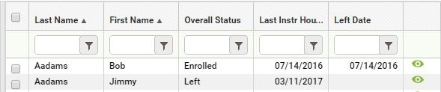
Tip: The 'Last Instr Hours Date' field is also on the student Education tab/Education panel.

Students can have a PoP that crosses the fiscal year, resulting in them counting on the NRS tables in both years, even if they did not have 12+ hours in the second fiscal year. For example, if a student attends with 12+ hours and a valid EFL from 2-11-17 until 7-5-17 and then exits without earning 12+ hours in 17/18, their period of participation crosses the fiscal year and they would still populate the 17/18 NRS tables even though they did not have 12+ hours in 17/18.

Scheduled Services
One of the major WOIA changes is the concept of Periods of Participation (PoP). While the student is enrolled and earning instructional hours without a 90+ day gap in activity, the student is in a PoP. Once the student completes all enrollments and leaves the program, or stops attending and is gone for 90+ days, the student begins a new PoP when they return.
However, a scheduled service by enrollment date or scheduled service start date overrides the 90+ day left rule.
The NRS states:
- Program exit occurs when the participant has not received services for the past 90 days and has no additional services scheduled. The date of exit is the last date on which the participant receives services.
How this works in LACES:

Scheduled Service | Rules | When to use
Class, group, or workshop enrollment that is scheduled during a student’s PoP but starts on a future date. The enroll date will be within the PoP but the enrollment start date will be in the future. Pairs are NOT scheduled services. | The scheduled service is based on the student enroll date in a class, group, or workshop - not the class or group start date.  The scheduled service is in effect until 90 days after the class or group start date if the student did not earn instructional hours. The student will then be 'left' in the appropriate PoP. A future class or group enrollment may cross the fiscal year boundary. | Use if your agency creates future classes, groups or workshops, and you are allowed to enroll the students in advance of the class, group, or workshop start date. For example:  - A student was in a PoP between 7/1 and 9/25 but is not currently enrolled.  - The student plans to return after the first of the year.  - Classes, groups, and workshops that do not begin until the new year are created with a start date in January.  - The student is then enrolled into these classes, groups, or workshops.  - The student must have an enroll date that falls within 90 days of the last PoP activity date, but the enrollment start date will be in January.  - The student will not be left if there is a gap of 90+ days without activity. However, the student must earn instructional hours within 90 days of the enrollment start date.  This is a scheduled service.  Pro: Staff/tutors assigned to teach these classes or groups can plan accordingly, since they know how many students will be attending. Con: Students may not return even though they are scheduled, and must either be deleted from the class or group, or the enroll status changed to Never Attended. This creates additional data entry and may affect student measurable outcomes follow up quarters.
Indicated by a 'Scheduled Service Start Date' entered in the student record at the Education tab/Education panel. This is the date a student is planning to begin a future service. | The scheduled service ‘expires’ 90+ days after that date if there has been no enrollment during that time, and the student will then be 'left' in the appropriate PoP. A Scheduled Service Start Date may cross fiscal year boundaries. | Use if your agency creates future classes or groups, but students are not allowed to be future enrolled. Or: If your agency does not create future classes or groups but needs a way to show that a student plans to return after a gap in activity. OR: If your agency creates future classes or groups, but students are not allowed to be future enrolled because of customized assessment rules. You want to indicate that a student will return but the student cannot be enrolled in a future class or group without a new assessment. (NOTE: check the User News at the '<ST> Customizations' link to see if your state or agency has customized assessment rules.) Pro: Allows you to indicate that a student plans to return but is not yet enrolled in a class or group, which prevents the student from being considered left. Con: The student may not return to be enrolled. If the student is not enrolled but is not considered left, you must remember to check the Scheduled Service Start Date field. The date can be deleted, but this may create additional data entry may affect student measurable outcomes follow up quarters. Also, when this date is entered, the student overall status may be left, and a Left Date displays in the student header field, but the PoP summary record will NOT display a left date.
Scheduled Service Start Date
- This student entered the program on 9/12/2016 and his last hours date was 9/28/2016. That was the student's last activity in the PoP. It has been more than 90 days since 9/28/2016, so the student is left. Notice that the Left Date in the student header and the Left Date in the PoP summary record are the same.
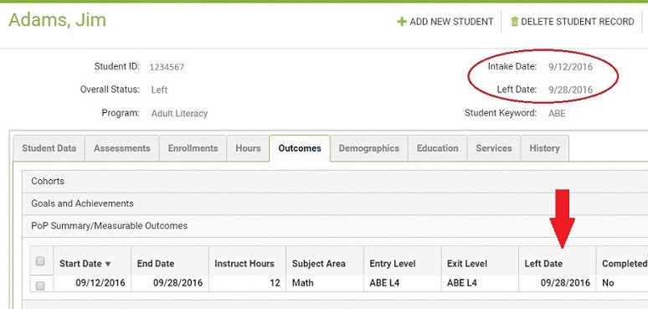

Now, assume that today's date is 3/24/2017. The student plans to return on 5/1/2017 but is not enrolled in a class or group. The date of 5/1/2017 is entered in the Scheduled Service Start Date field.
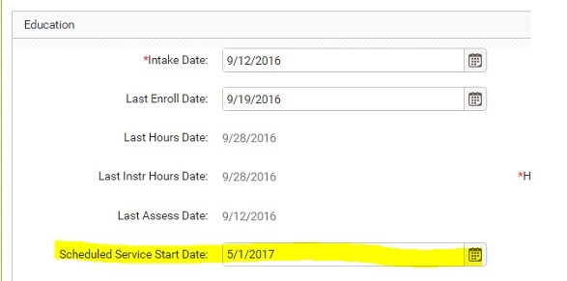
The student is no longer considered left because he has a scheduled service. However, notice that his overall status is still Left and the Left Date of 9/28/2016 still displays in the student header, but his PoP summary record does NOT display a left date.

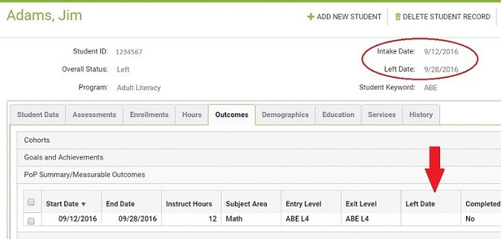
Q: When will Jim be considered left in the PoP?
A: If Jim does not enroll in a class or group within 90 days of 5/1/2017 (approximately 8/1/2017), his original left date of 9/28/2016 will re-populate in the PoP summary record. This may affect follow up for his outcome measures.
If the date is deleted from the field, the left date will re-populate in the PoP summary record.

Scheduled Enrollment
- Using the same student from the example above, the last activity in his first PoP was 9/28/2016. There is no date in the Scheduled Service Start Date field.
- The student was, however, enrolled in a class that is scheduled to begin on 5/1/2017.
- If the student's enrollment date in the class is within 90 days of 9/28/2017, he will not be considered left. In this example, his enrollment date was 10/15/2016, which is within 90 days of his left date of 9/28/2016.
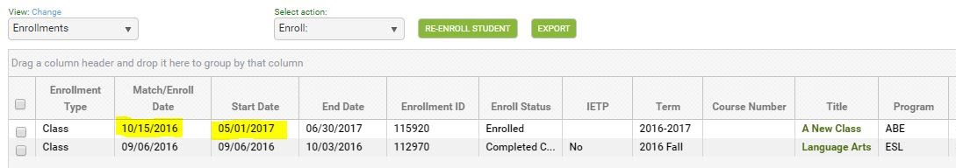

Q: When will Jim be considered left in the PoP?
A: If Jim does not earn instructional hours within 90 days of the class start date, his original left date of 9/28/2016 will re-populate in the PoP summary record. This may affect follow up for his outcome measures.
You may delete Jim's enrollment record in the class if he does not return. When the enrollment is deleted, the left date will repopulate in the PoP summary record.
It is important to utilize Scheduled Services only as directed by your state policy. When a student has a scheduled service, they are not left unless the scheduled services requirements have not been met. This is important for employment, obtain secondary credential, and entered postsecondary follow up. Make sure you are following your state policy regarding scheduled services.

Printing/Saving the New NRS Tables
The new NRS tables for fiscal year 2016-2017 are not on the report manager but instead are located on the student NRS table searches. The searches for 2016-2017 tables have been updated to include the total rows and NRS instructions for completing the new tables. This change was introduced in Release 2017.1.0.
1. Click the <Searches link at the student area.
2. Expand the NRS category.
3. Select one of the new tables - NRS tables 1, 2, 3, or 6.
4. Select NRS FY 16-17 on the drop-down list at the 'Select Reporting System' field.
5. The new report will display. From here, you may print the report by clicking the Print icon at the top right.
6. Click any of the cells to drill down to the list of students populating the cell.
The correct table format will display once you select the Reporting System. For example, if you select NRS FY 15-16, the table format appropriate for that reporting year will display. If you select NRS FY 16-17, the new table for that reporting year will display.

Q: How do I save the new table?
A: Most browsers have a built-in PDF printer that allows you to 'print' and save any file to PDF.

To print an NRS table to PDF:
  - First, follow the steps above to display an NRS table using the <Searches link.
  - Click the printer icon on the window.
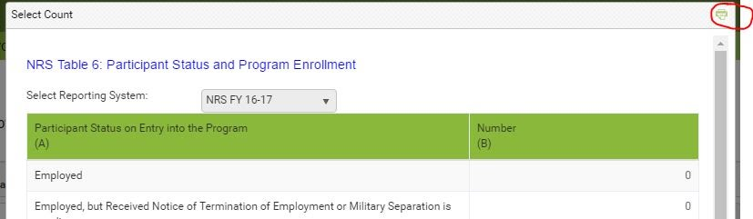
  - The 'PrintFriendly' window will display
  - Click the Print button at the bottom of the window.
  - The printer dialog window will display. Depending on your browser and/or printer, you will see:
- Chrome: Destination/Change
- Firefox: Name field with a drop-down list
- IE: 'Select Printer' area

6. Depending on your browser/printer, you will then:
- Chrome: Click the Change button and select 'Save as PDF'
- Firefox: Select 'Microsoft Print to PDF.'
- IE: Select 'Microsoft Print to PDF.

7. Depending on your browser and/or printer, you will then:
- Chrome: Click the Save button
- Firefox: Click the OK button
- IE: Click the Print button

8. Select a location on your computer drive, enter a name for the file, and click Save.
9. The table is now saved as a file on your computer. You can locate the file, open, then print.

IMPORTANT NOTE: Be sure to look at the print dialog box the next time you print a file. You may have to change the destination or printer, back to your default printer name.

